ITAS USER GUIDE
DOCMAN (DOCUMENT MANAGEMENT)

Version 1.1 May 2017

Copyright © 2017 Hivedome Ltd. All Rights Reserved

Contents

Introduction 1
LAUNCHING ITAS 2
LAUNCHING DOCMAN MENU 3
Adding New Documents to DOCMAN 5
UPLOADING DOCUMENTS VIA THE SMART PANEL 5
CONDITIONAL MANDATORY 8
UPLOADING DOCUMENTS VIA MENU ITEMS 14
CONDITIONAL MANDATORY 17
UPLOADING DOCUMENTS VIA WINDOWS EXPLORER 23
CONDITIONAL MANDATORY 23
Unindexed Documents 27
LAUNCHING UNINDEXED DOCUMENTS 27
INDEXING DOCUMENTS 28
ADDING A TRADING ENTITY 29
ADDING A DOC. TYPE 31
ADDING MULTIPLE INDEXES 33
CONDITIONAL MANDATORY 33
DOCUMENT SEARCHING 40
SAVING DOCUMENT SEARCHES 41
SORTING THE DOCUMENT LIST 43
FILTERING THE DOCUMENT LIST 45
ADVANCED FILTERING 48
FILTER LOGIC 49
OPERATORS 50
SAVING FILTERS FOR FUTURE USE 53
APPLYING A SAVED FILTER 54

Company Documents 55
LAUNCHING COMPANY DOCUMENTS 55
DOCUMENT SEARCHING 56
SAVING DOCUMENT SEARCHES 57
SORTING THE DOCUMENT LIST 59
FILTERING THE DOCUMENT LIST 61
ADDING COLUMNS 64
REORDERING COLUMNS 66
FILTERING BY DATE 67
ADVANCED FILTERING 70
FILTER LOGIC 71
OPERATORS 72
SAVING FILTERS FOR FUTURE USE 75
APPLYING A SAVED FILTER 76
EDITING DOCUMENTS 77
DOCUMENT PROPERTIES 79
CONDITIONAL MANDATORY 81
ARCHIVING DOCUMENTS 87
Archived Documents 93

Introduction
DOCMAN is the ITAS Document Management interface and enables users to store documents and associate them with Contracts, Documents, WIP or Client Accounts.

In addition DOCMAN allows the entry of searchable information that is stored with each document. This can include contract number, counter-party, TRADE Group No, commodity codes, Vessel names, Container Ids, WIP reference and a free-form search parameter.

The customisable DOCMAN grid style screens provide quick and easy searching of indexed and unindexed documents across all visible columns as well as offering users the ability to access, edit and organise them too.

The DOCMAN program forms only part of the ITAS document management functionality that includes the auto-indexing of system-generated documents and document index search facilities in TRADE, CLI and WIP. Every document can also be indexed with the details of which DOCDES template best fits the style e.g. Broker Advice, Shipping Notification, Customs Clearance.

For more information on the full range of ITAS document management features contact Hivedome.

LAUNCHING ITAS
From the computers desktop locate the ITAS 8.0 short cut:

Double click to launch ITAS

If a shortcut is not available on the desktop navigate to the following directory:

C:\ITAS-NG\Wpf\Src

Locate the Hivedome.Itas.Shell.exe application and double click to launch ITAS 8.0.

Once ITAS is launched the ITAS Trader Desktop will display.

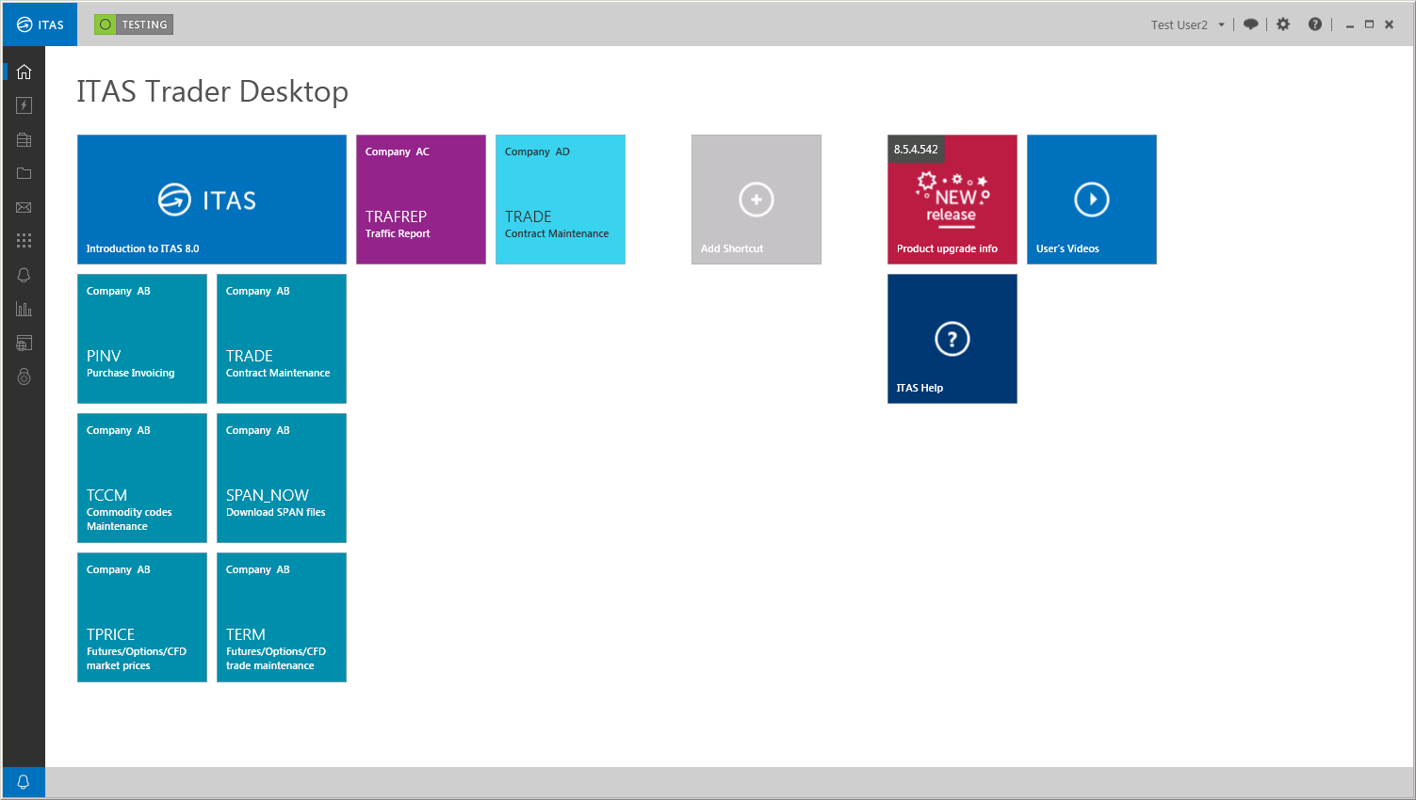

LAUNCHING DOCMAN MENU
Users can access the DOCMAN Menu to upload and index new documents and search for existing documents via Trader Desktop.

To launch DOCMAN click in the Navigation Panel.

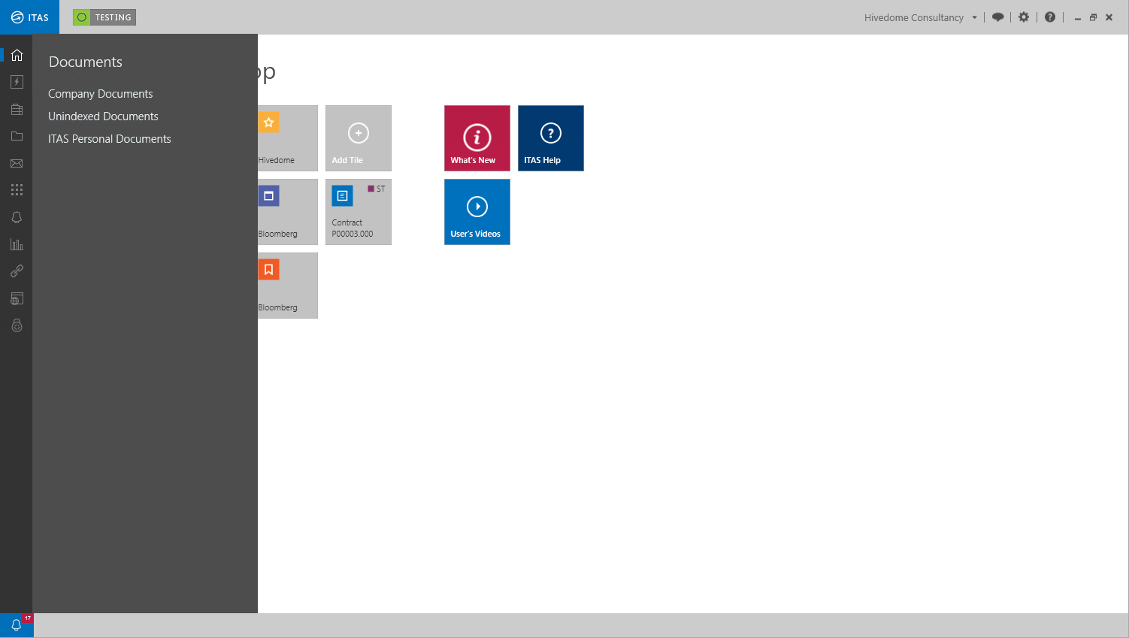

The DOCMAN Menu provides access to three screens:

Company Documents | Enables users to upload and manage indexed Company Documents.
Unindexed Documents | Provides access to all unindexed Company Documents and enables users to assign additional indexes to assign them to the relevant company, contract, CLI account etc. Once documents are fully indexed they will be removed from the list of Unindexed Documents and will be displayed in Company Documents.
Personal Documents | Enables users to create, maintain and manage personalised Rich Text, MS Word and MS Excel documents. These documents can also be organised into folders or directories.

Adding New Documents to DOCMAN
DOCMAN is able to add most types of documents to ITAS including those from the Microsoft Office suite of applications, .pdfs and .rtf files.

Documents can be added one by one or as part of a group. They can also be can be added in three different ways:

- Uploaded via the DOCMAN tab on the Smart Panel
- Uploaded directly to a record via a menu item, i.e. a contract via TRADE
- Dropped directly in the DOCMAN folders via Windows Explorer

UPLOADING DOCUMENTS VIA THE SMART PANEL
To upload new documents to ITAS click in the DOCMAN Menu.

In the Menu Bar at the top of the Company Documents screen click to launch the Smart Panel and the DOCMAN tab.

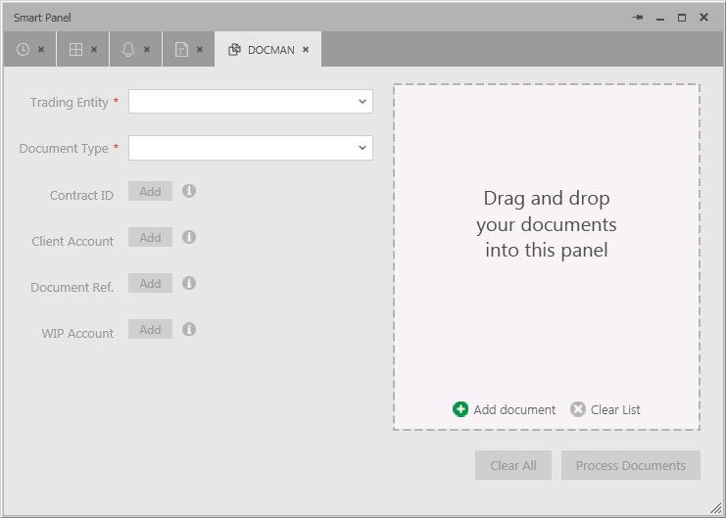

Alternatively click in the Navigation Panel to launch the Smart Panel and the DOCMAN tab.

To add new documents to DOCMAN drag and drop them into the Progress Panel.

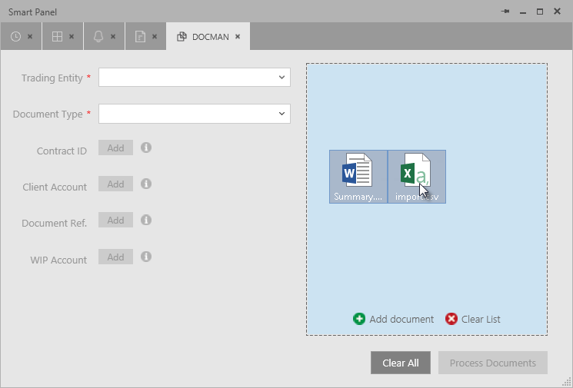

To select a document via a Windows Open screen click 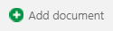. Navigate to the relevant directory to locate the documents.

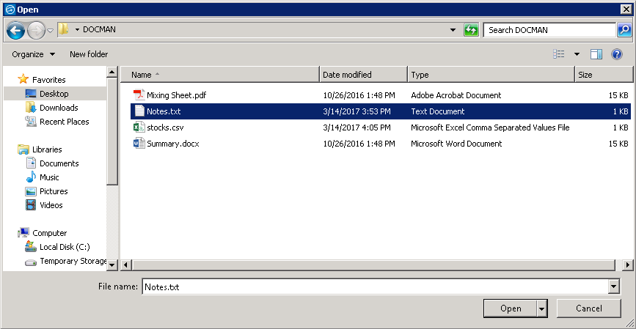

Select the documents to be uploaded and click to begin the upload process.
Each document will now appear in a list in the DOCMAN progress panel. Each document will appear with a yellow marker - indicating that its current Status is Pending and a percentage uploaded set at 0%.

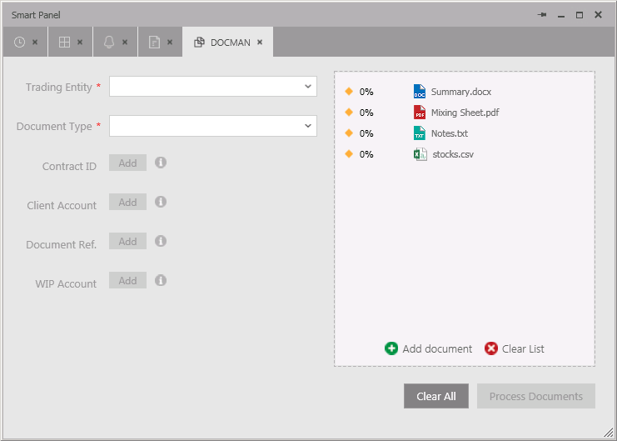

If an incorrect document was selected it can be removed from the Progress Panel.

Hover the cursor over the document and click .

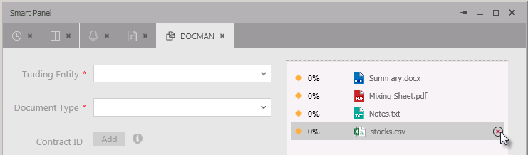

To remove all documents from the Progress Panel click .

New documents can be indexed by assigning the following properties:

- Trading Entity
- Document Type
- Contract ID
- Client Account
- Document Ref
- WIP Account

Trading Entity and Document Type are mandatory and must be assigned before any other properties, such as Contract ID can be assigned. Mandatory fields are highlighted with a .

Select the Trading Entity the document will be associated with and the Document Type from their dropdown lists.

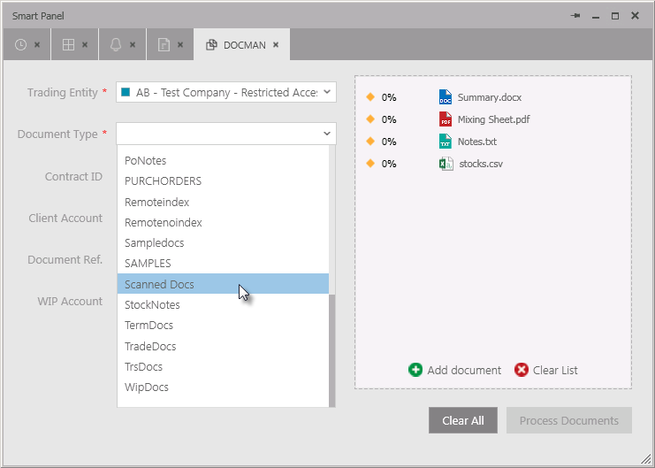

Once a Document Type has been selected the remaining index fields and the button will become active.

CONDITIONAL MANDATORY
Although documents can be uploaded without any additional indexes being adding at this point, it is recommended that as many as possible are added. This will ensure documents are associated with the relevant contract or account and that they can be viewed via the relevant menu items.

The Document Type field employs the use of conditional mandatory rules, this means that any of the four indexes below, Contract ID. Client Account, Document Ref. or WIP Account may become mandatory depending on the Document Type chosen.

For example, if the Scanned Documents option is selected none of the indexes become mandatory:

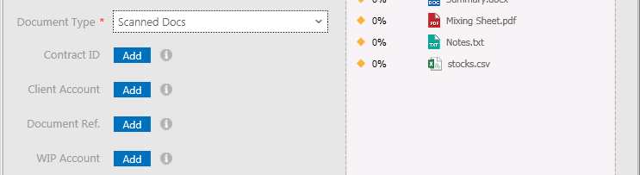

But if the Invoices option is selected then a Contract ID and a Document Reference index must be added to the document.

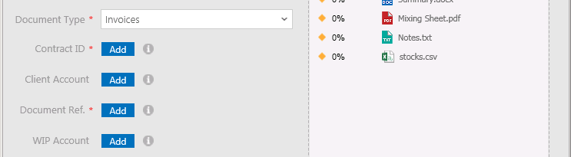

Conditional mandatory rules can be reconfigured to include whatever additional indexes if required. Contact Hivedome for assistance.

To add additional indexes click next the appropriate Index.

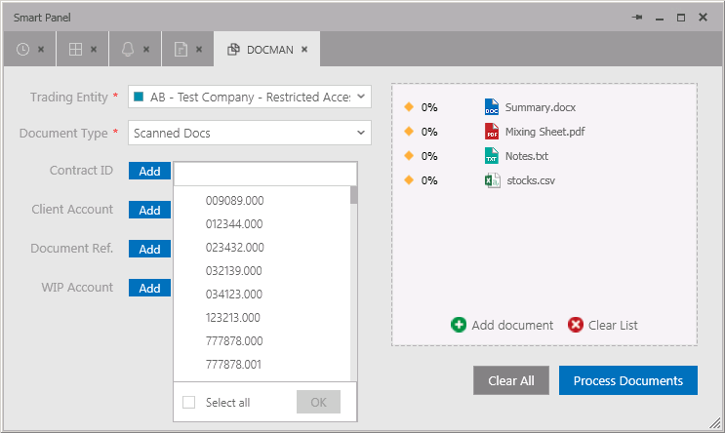

Scroll down the list and choose an index from the drop down by placing a tick the relevant checkbox.

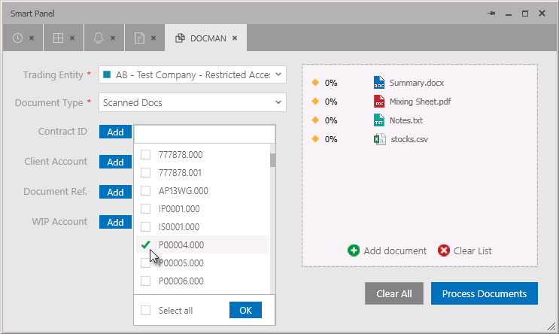

Click to confirm the selection.

These fields also have search fields that can be used to filter out specific indexes.
To search for an index click and place the cursor in the field at the top of the drop down list and begin typing in the search criteria to activate the predictive search function.

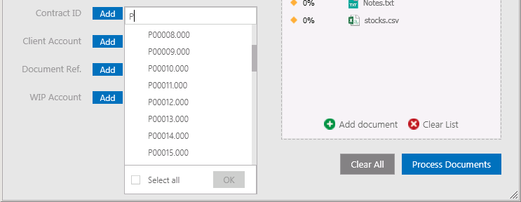

This works by filtering further as more data is keyed in.

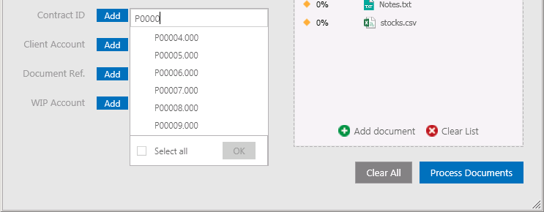

Select an index from the drop down by placing a tick the relevant checkbox.

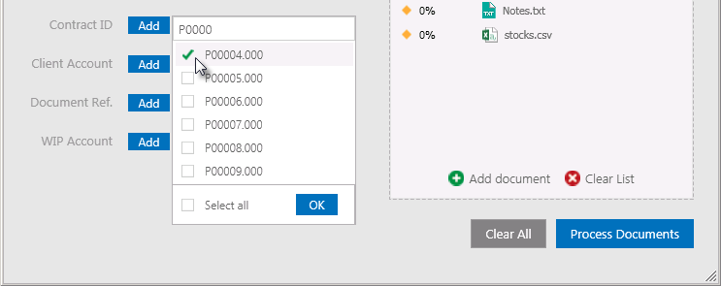

Click to confirm the selection.
Once all of the required indexes have been assigned the documents can be uploaded to DOCMAN.

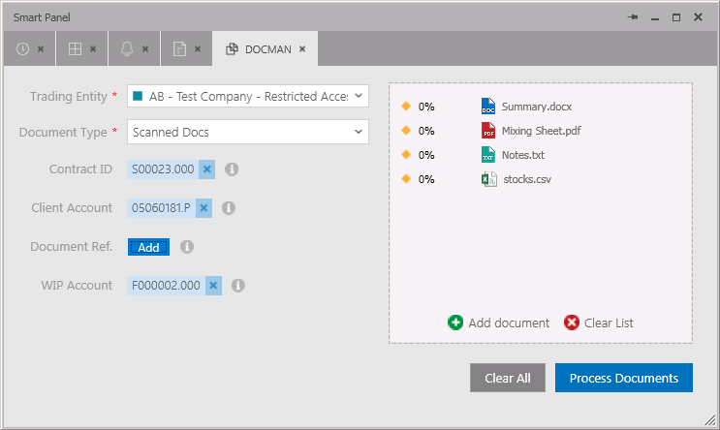

To upload documents click . While the documents are being processed there status will change to in progress which is signified with a blue marker -

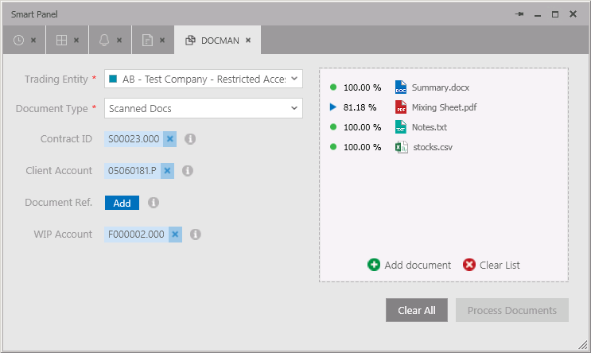

Once a document has been uploaded the marker will change - , the percentage uploaded should read 100% and the following message will appear:
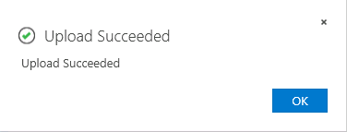

Click to continue.
Uploaded documents can now be viewed in Company Documents. Click in the Navigation Panel to launch DOCMAN and select .

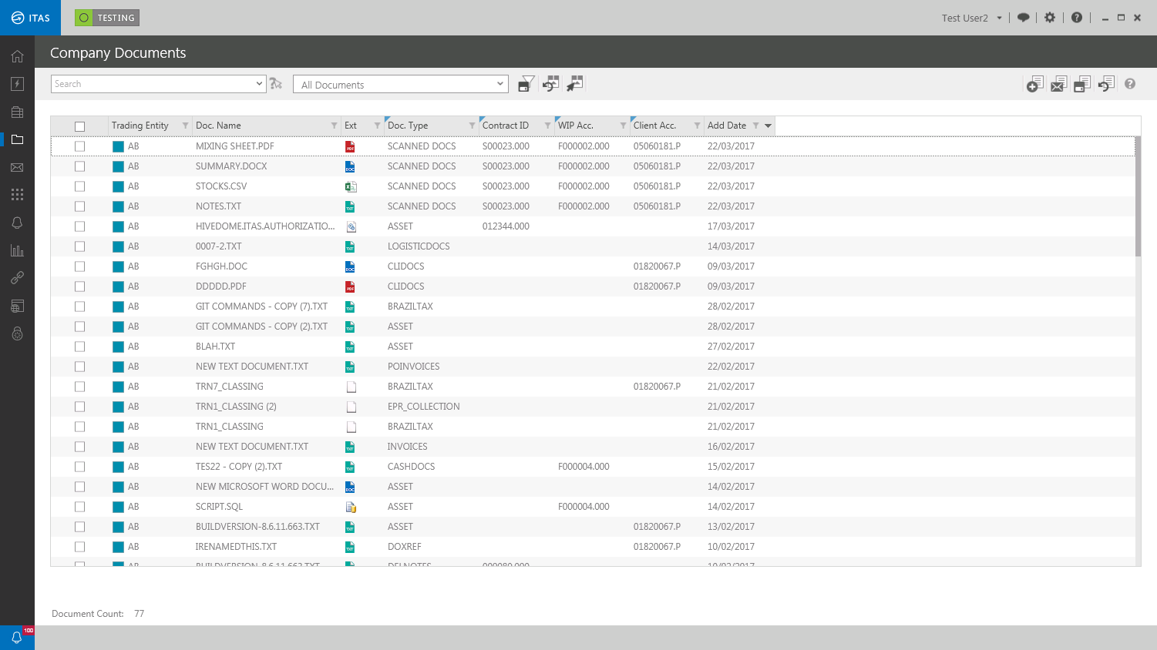

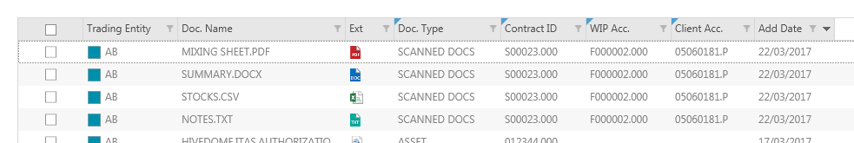

Documents can now be opened for viewing and editing. Their properties can also be edited including the addition of further indexes added.

UPLOADING DOCUMENTS VIA MENU ITEMS
To upload new documents to an existing ITAS record first launch the relevant Menu Item and recall the required record.

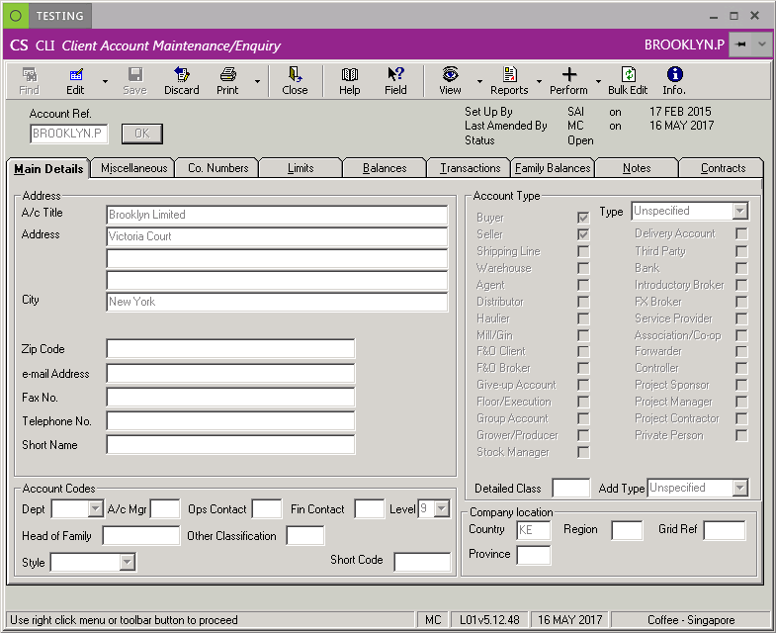

In the banner at the top of the screen click to reveal a dropdown menu.

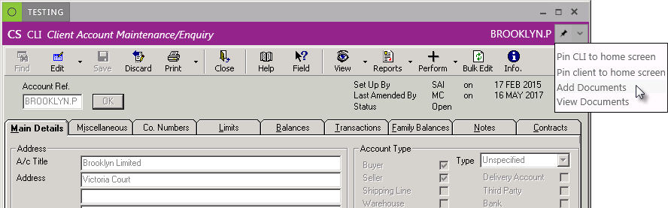

Select Add Documents to launch the DOCMAN panel.

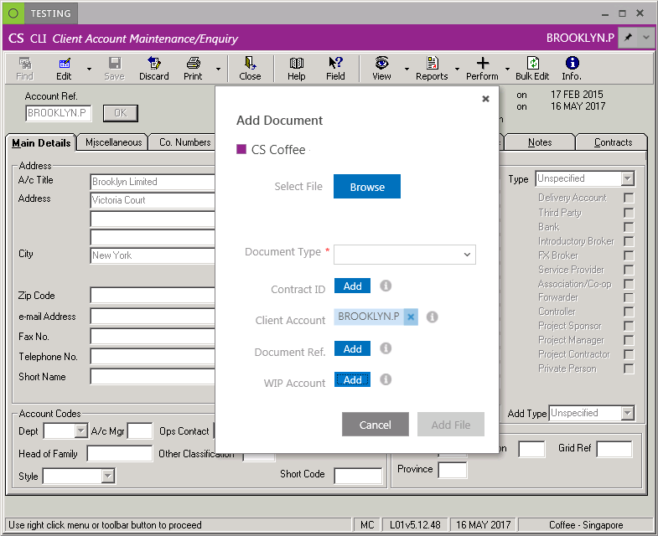

To select a document via a Windows Open screen click . Navigate to the relevant directory to locate the documents.

Select the documents to be uploaded and click to begin the upload process.
The selected document will be displayed on the DOCMAN panel.

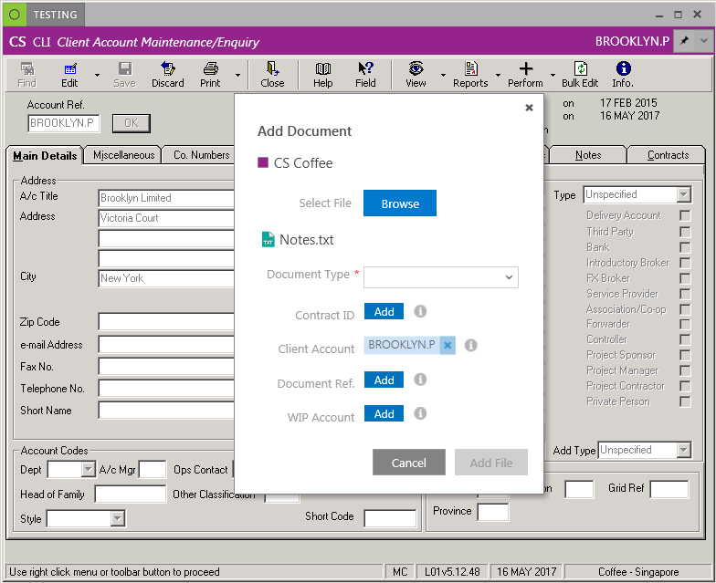

The new document will automically be indexed with the Trading Entity that the record the document is being added to belongs.

Further indexes can be assigned by selecting one or more of the following properties:

- Document Type
- Contract ID
- Client Account
- Document Ref
- WIP Account

NOTE
ITAS will automatically assign indexes to the new document depending on the type of record it is being added to. In the example above Client Account was assigned because the document was added to a CLI account.

Trading Entity and Document Type are mandatory and must be assigned before any other properties, such as Contract ID can be assigned. Mandatory fields are highlighted with a .

Select the Trading Entity the document will be associated with and the Document Type from their dropdown lists.

CONDITIONAL MANDATORY
Although documents can be uploaded without any additional indexes being adding at this point, it is recommended that as many as possible are added. This will ensure documents are associated with the relevant contract or account and that they can be viewed via the relevant menu items.

The Document Type field employs the use of conditional mandatory rules, this means that any of the four indexes below, Contract ID. Client Account, Document Ref. or WIP Account may become mandatory depending on the Document Type chosen.

For example, if the Scanned Documents option is selected none of the indexes become mandatory:

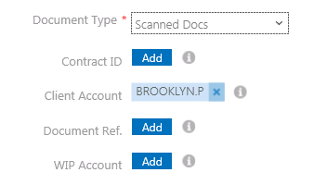

But if the Invoices option is selected then a Contract ID and a Document Reference index must be added to the document.

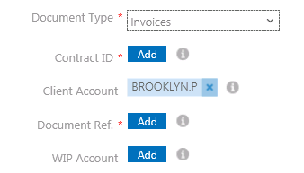

Conditional mandatory rules can be reconfigured to include whatever additional indexes if required. Contact Hivedome for assistance.

To add additional indexes click next the appropriate Index.

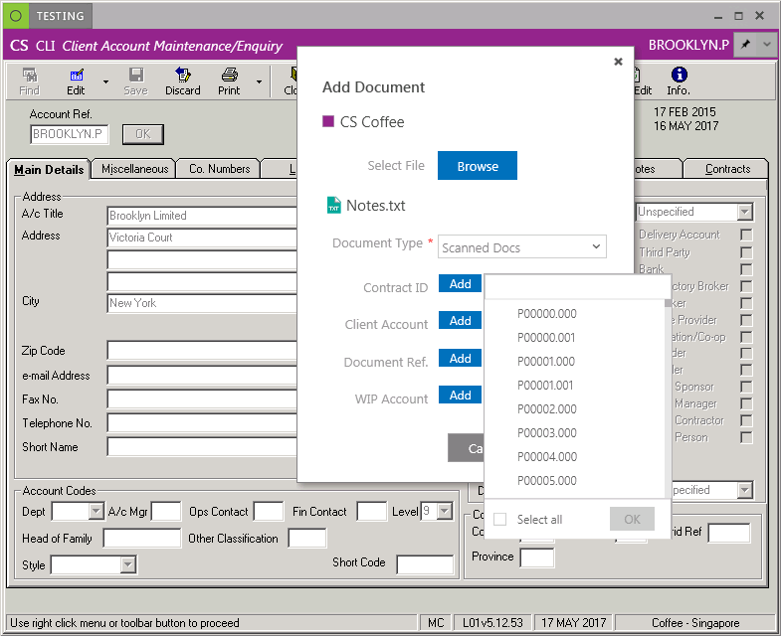

Scroll down the list and choose an index from the drop down by placing a tick the relevant checkbox.

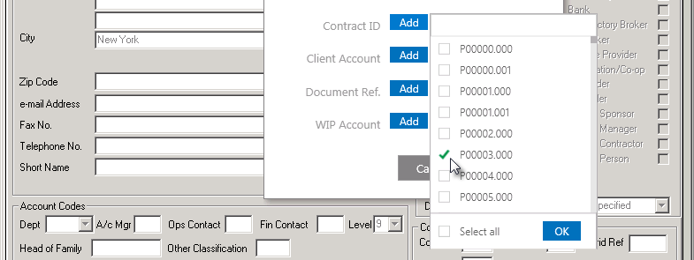

Click to confirm the selection.

These fields also have search fields that can be used to filter out specific indexes.

To search for an index click and place the cursor in the field at the top of the drop down list and begin typing in the search criteria to activate the predictive search function.

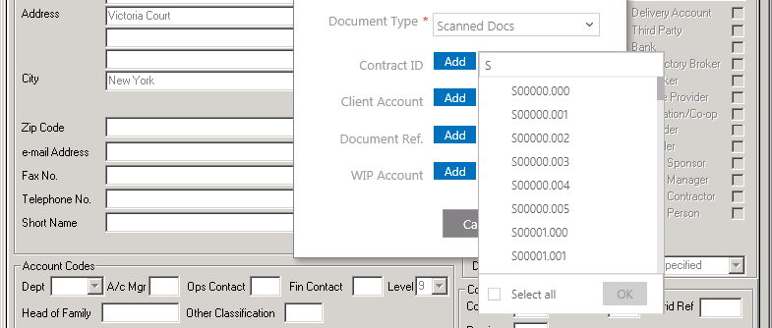

This works by filtering further as more data is keyed in.

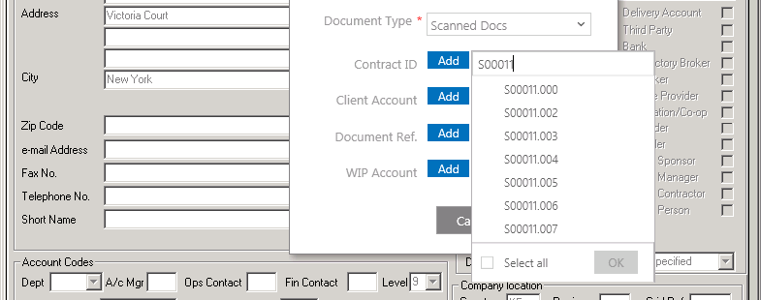

Select an index from the drop down by placing a tick the relevant checkbox.

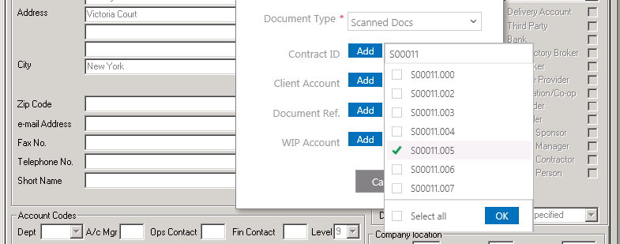

Click to confirm the selection.
Once all of the required indexes have been assigned the documents can be uploaded to DOCMAN.

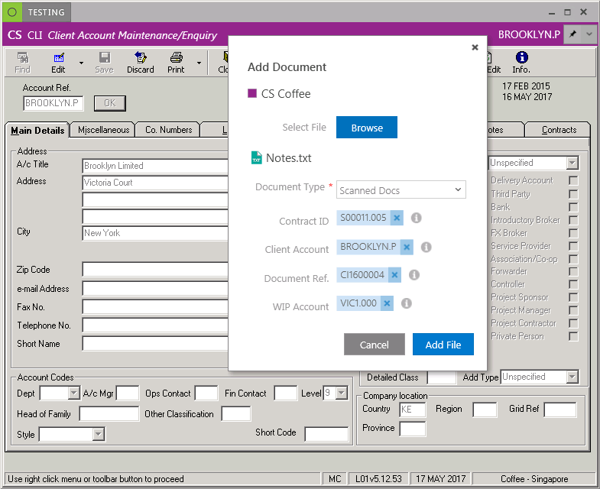

To upload documents click .

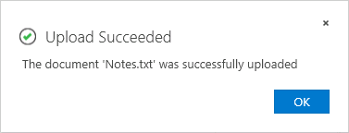

Click to continue.

Uploaded documents can now be viewed by clicking to reveal a dropdown menu.

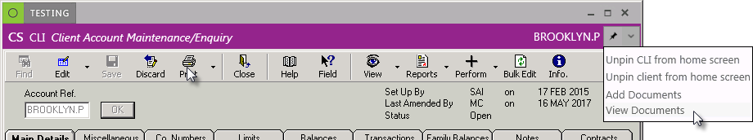

Select View Documents to launch the DOCMAN panel.

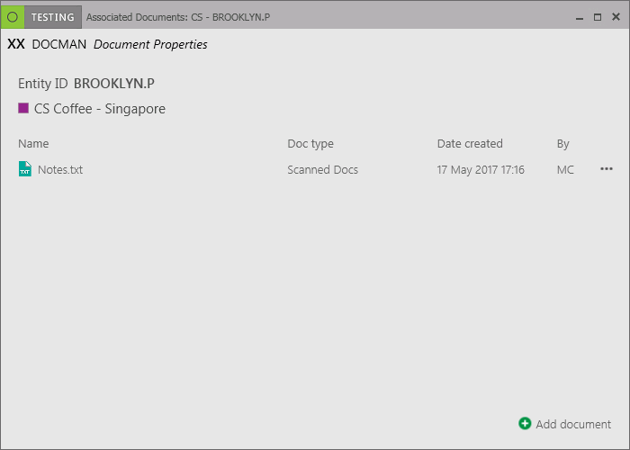

KEY POINT

Documents can also be viewed using the Ctrl & M Keyboard shortcut

Documents can also be viewed in Company Documents. Click in the Navigation Panel to launch DOCMAN and select .

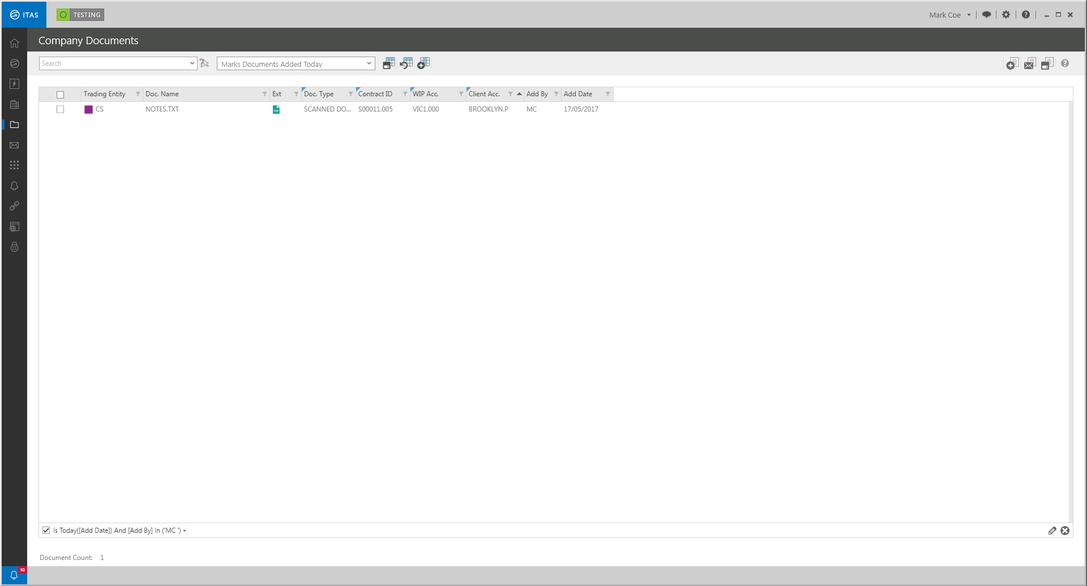

Documents can now be opened for viewing and editing. Their properties can also be edited including the addition of further indexes added.

UPLOADING DOCUMENTS VIA WINDOWS EXPLORER
Documents can be placed directly into DOCMAN folders via windows explorer. To add documents directly to the DOCMAN folders navigate to the following folder on the server:

C:\itas\Comp

The Comp folder contains a series of folders, one for each ITAS company that store company documents. Subfolders with these company folders group documents by type. Comp also contains a DroppedFiles folder where documents can be placed ready to be indexed via the Unindexed Documents screen within ITAS.

It is also possible to configure the DroppedFiles folder so that documents placed in it will be indexed automatically. Documents can have Company and DocType details added to them if placed in relevant subfolders within DroppedFiles.

Documents placed in the following locations will be indexed as follows:

/DroppedFiles | Documents will not be indexed automatically but will be available in the Unindexed Documents screen where they can be manually.
/DropFolder/BI | Documents will be automatically indexed with BI (or relevant company details) but will be available in the Unindexed Documents screen where further indexes such as Document Type for example can be added manually.
/Dropfolder/AB/Invoice | Documents will be automatically indexed with AB (or relevant company details) and Invoice (or relevant Document Type). They will then be available in the Company Documents.

An ITAS service is configured to run and index documents within the DOCMAN folders every ten seconds but can be configured to run at different internals if preferred. Any files found that meet the auto index criteria will be processed, i.e. indexed and moved to the relevant folder. Those that do meet the index criteria will remain in the DroppedFiles folder and remain in the Unindexed Documents screen.

The auto indexing service can also be configured to index some Companies and not others where documents may require manual processing.

It is also possible to change the ‘Folder to watch’ to include multiple locations and sub-folders, so if it is prefer that documents are to be placed in another DOCMAN folder for indexing instead of .the DroppedFiles this can be configured by Hivedome.

CONDITIONAL MANDATORY
The same conditional mandatory rules will be applied to documents placed directly in DOCMAN folders that would be applied to documents uploaded via DOCMAN within ITAS.

The documents below were placed in the DroppedFiles folder or one its subfolders and can now be see in Unindexed Documents:

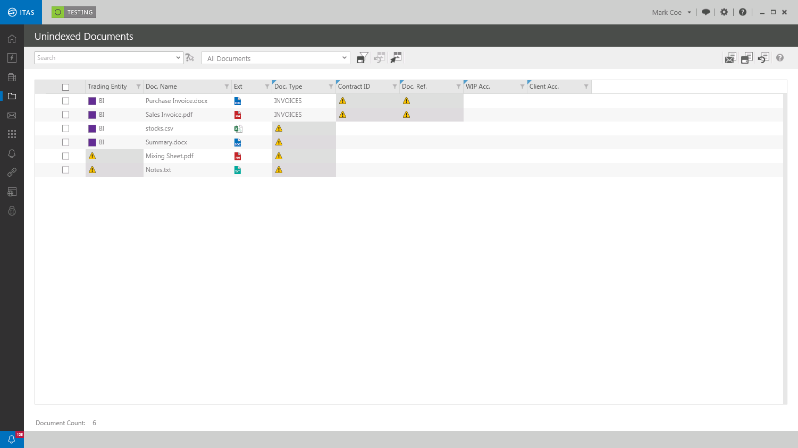

The first two files were placed in the following folder:

\DroppedFiles

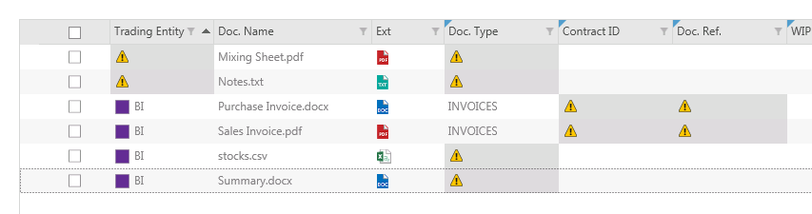

These documents were not automatically indexed therefore the Trading Entity and Doc. Type will need to be added manually before they will be visible in the company documents screen.

Further indexes will also need to be added to ensure these documents can be retrieved via any relevant menu items, CLI accounts and contracts.

The second two files were placed in the following folder:

\DroppedFiles\BI\Invoices

These documents were automatically indexed with the BI company details and with the Document Type. The remain in the Unindexed Documents folder however because the conditional mandatory rules require the addition of the Contract ID and Doc. Ref indexes to be added to this document type which will need to be added manually before they will be visible in the company documents screen.

The second two files were placed in the following folder:

DroppedFiles\BI

These documents were automatically indexed with the BI company details only. Doc. Type will need to be added manually before they will be visible in the company documents screen.

Further indexes will also need to be added to ensure these documents can be retrieved via any relevant menu items, CLI accounts and contracts.

Unindexed Documents
Unindexed Documents will display a list of documents that have been uploaded directly to the DroppedFiles folder via ITAS via Windows Explorer where the documents indexes do not meet the minimum requirements set out in the conditional mandatory rules.

This screen enables users to assign additional indexes to assign them to the relevant company, contract, CLI account etc. Once documents are fully indexed they will be removed from the list of Unindexed Documents and will be displayed in Company Documents.

LAUNCHING UNINDEXED DOCUMENTS
To launch the DOCMAN Menu click in the Navigation Panel.

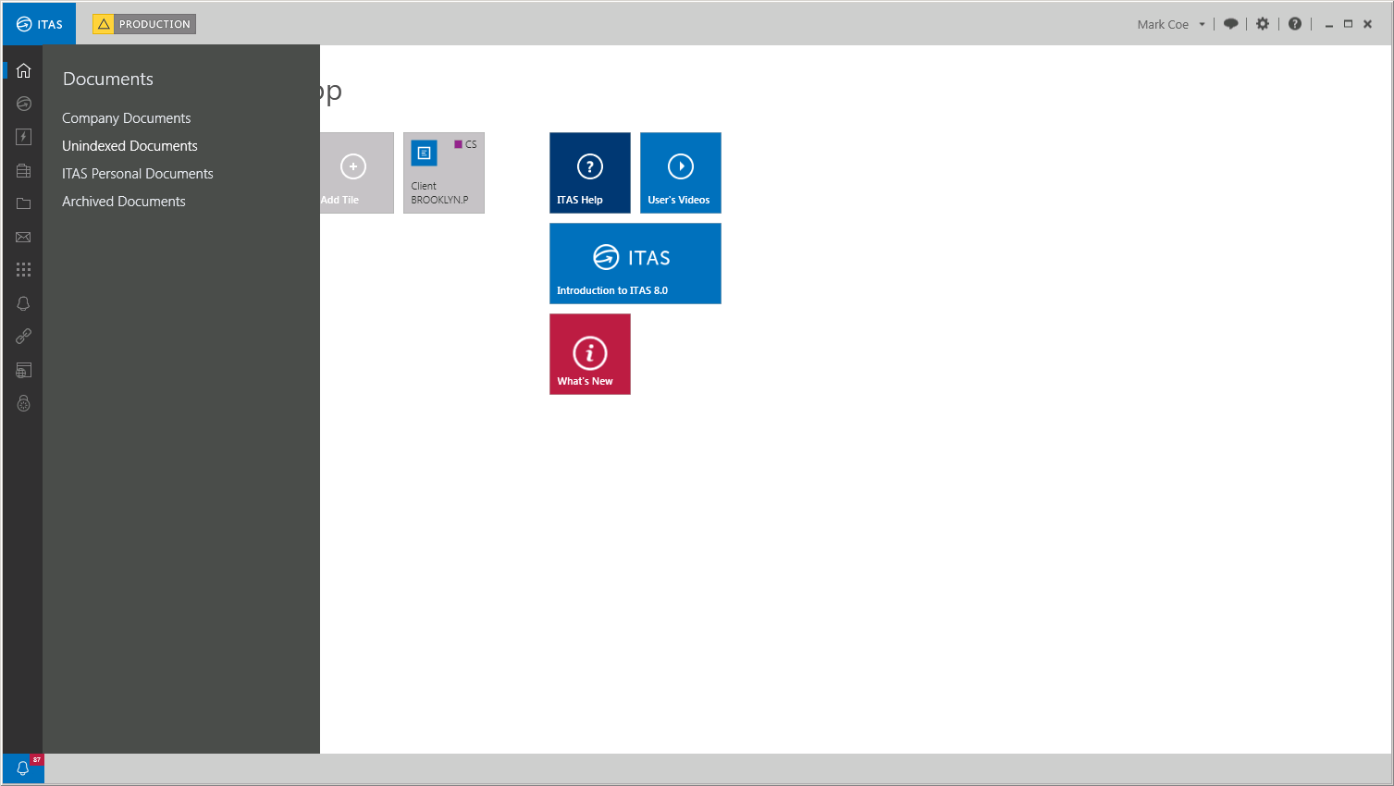

Click to view a list of unindexed documents.

All unindexed documents will be displayed.

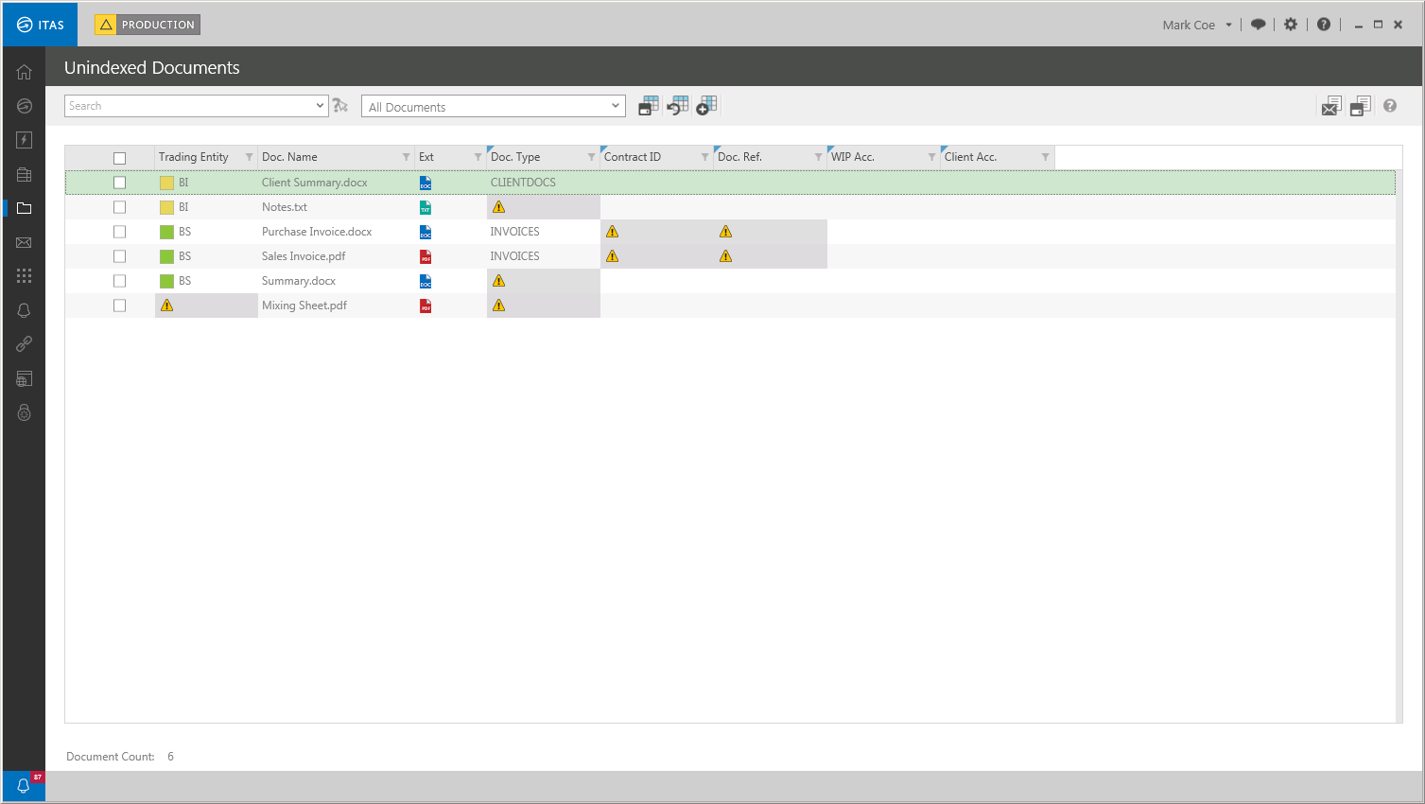

INDEXING DOCUMENTS
Each index missing from a document will be highlighted with a . The document below will require the following indexes to ensure it is fully indexed and before ITAS will move it to the Company Documents screen:

- Trading Entity
- Doc. Type

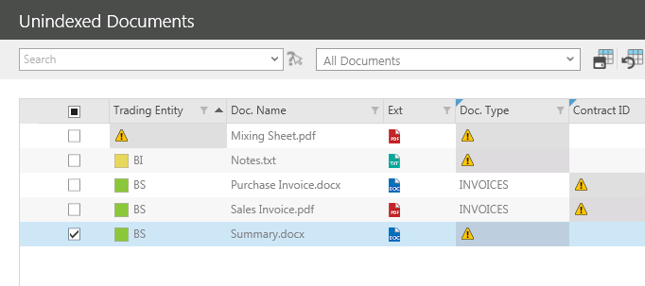

ADDING A TRADING ENTITY
To index a document with a Trading Entity right click on the relevant document and select Assign Trading Entity. A list of Trading Entities the user has access to will appear, select the relevant Trading Entity index.

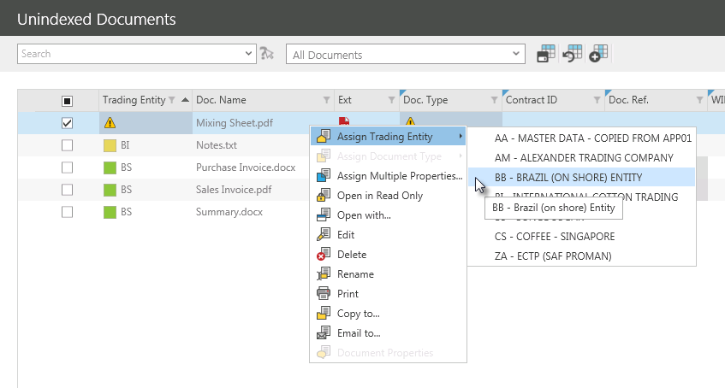

The document will now be assigned to the selected Trading Entity.

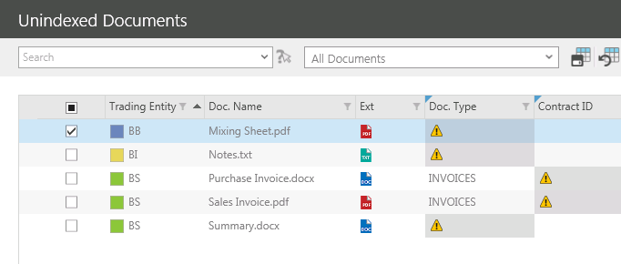

To add a Trading Entity to multiple documents with the same

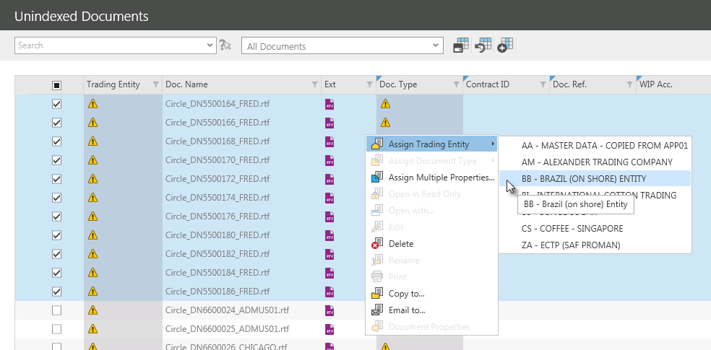

All documents will now be assigned to the selected Trading Entity.

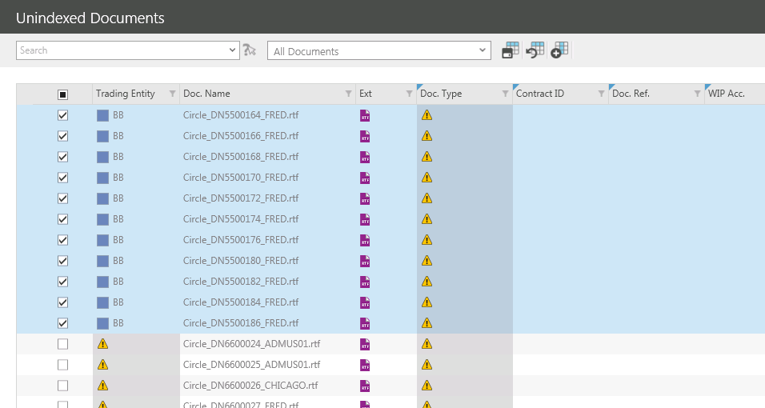
ADDING A DOC. TYPE
To index a document with a Doc. Type right click on the relevant document and select Assign Doc. Type. A list of Doc. Types will appear, select the relevant Doc. Type index.

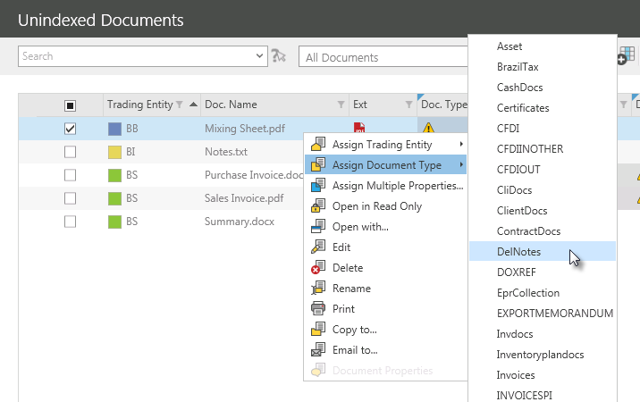

The document will now be assigned the selected Doc.Type.

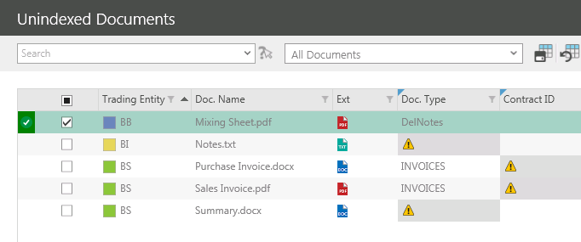

To add a Doc. Type to multiple documents with the same

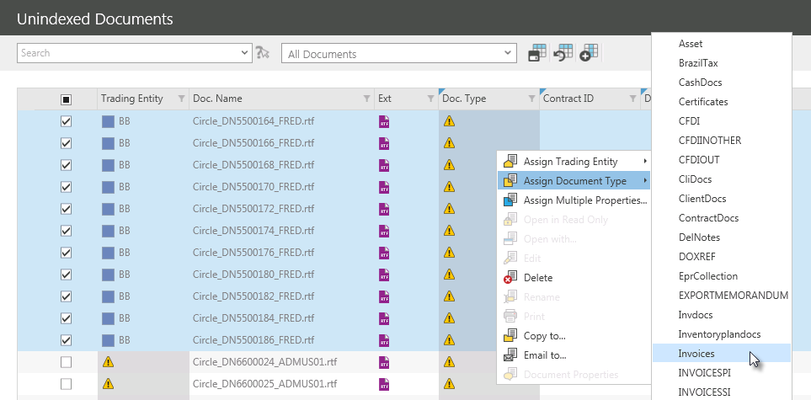

All documents will now be assigned to the selected Doc. Type.

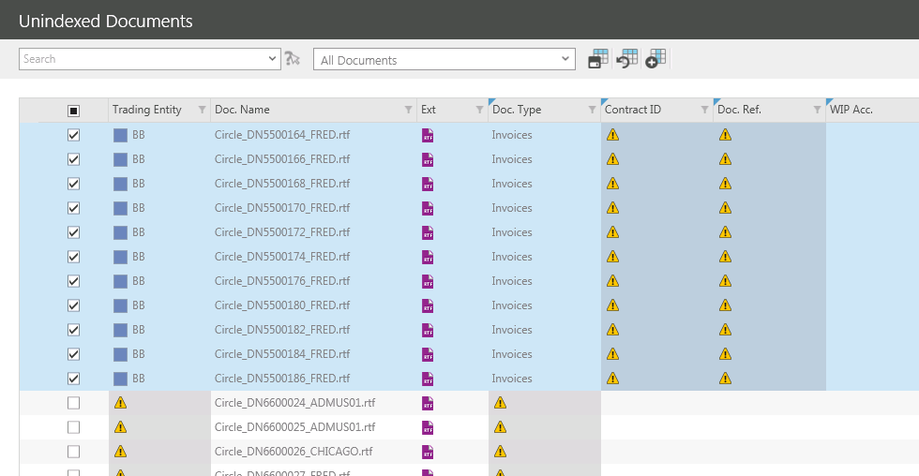

ADDING MULTIPLE INDEXES
To index a document with any other available index types, right click on the relevant document and select Assign Multiple Properties…. The Assign Multiple Properties screen will appear.

Documents can be indexed by assigning the following properties:

- Trading Entity
- Document Type
- Contract ID
- Client Account
- Document Ref
- WIP Account

Trading Entity and Document Type are mandatory and must be assigned before any other properties, such as Contract ID can be assigned. Mandatory fields are highlighted with a .

Select the Trading Entity the document will be associated with and the Document Type from their dropdown lists.

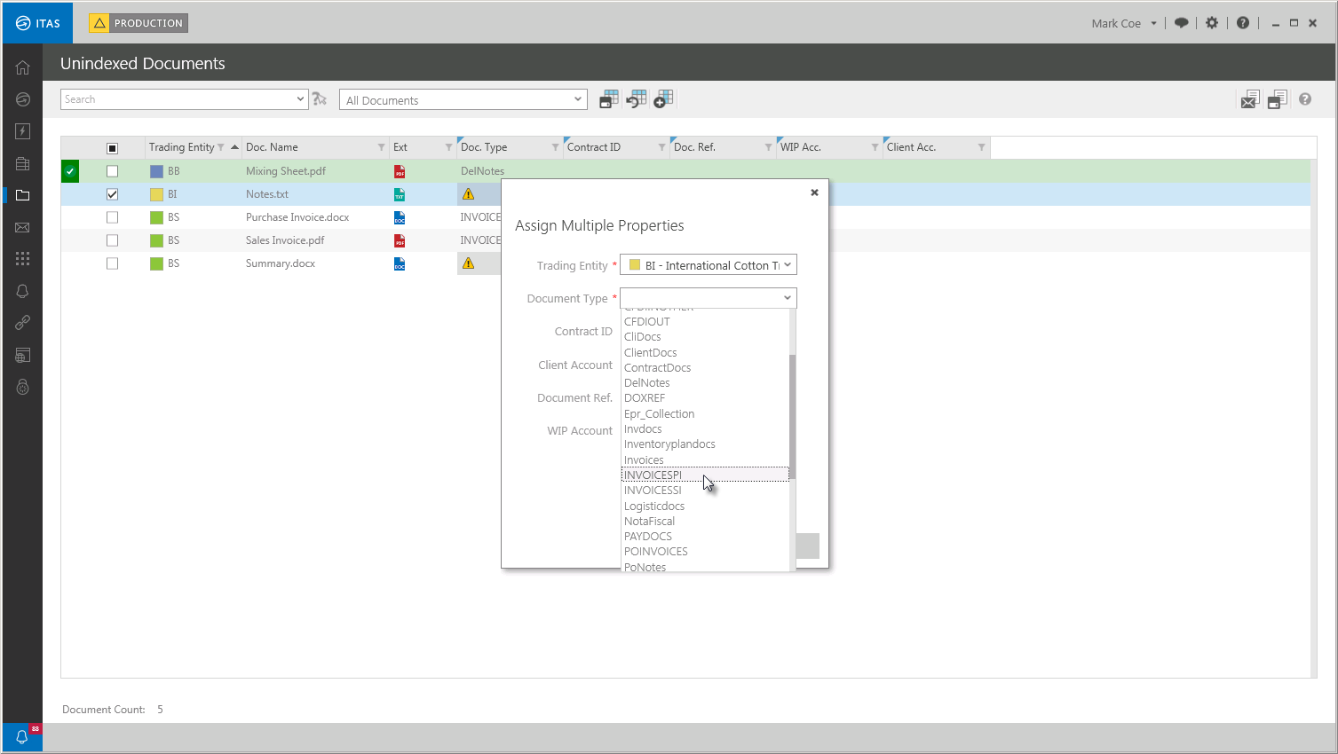

CONDITIONAL MANDATORY
The Document Type field employs the use of conditional mandatory rules, this means that any of the four indexes below, Contract ID. Client Account, Document Ref. or WIP Account may become mandatory depending on the Document Type chosen.

For example, if the Scanned Documents option is selected none of the indexes become mandatory:

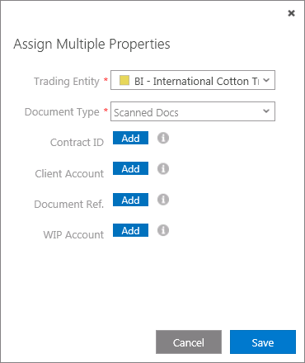

But if the Invoices option is selected then a Contract ID and a Document Reference index must be added to the document.

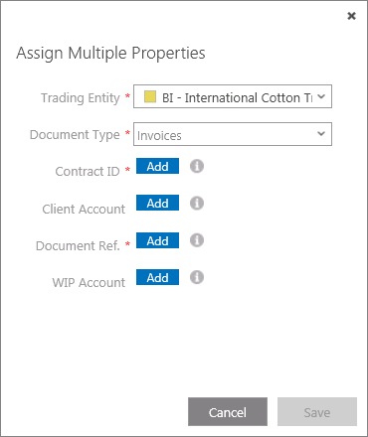

Conditional mandatory rules can be reconfigured to include whatever additional indexes if required. Contact Hivedome for assistance.

To add additional indexes click next the appropriate Index.

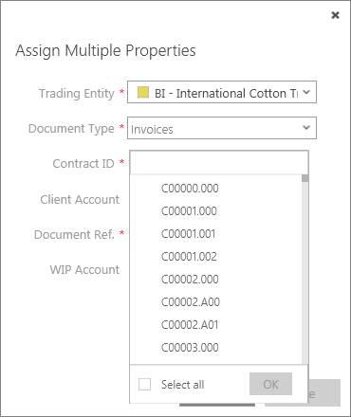

Scroll down the list and choose an index from the drop down by placing a tick the relevant checkbox.

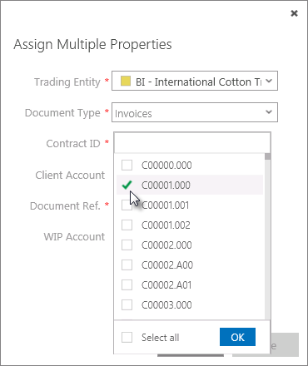

Click to confirm the selection.

These fields also have search fields that can be used to filter out specific indexes.

To search for an index click and place the cursor in the field at the top of the drop down list and begin typing in the search criteria to activate the predictive search function.

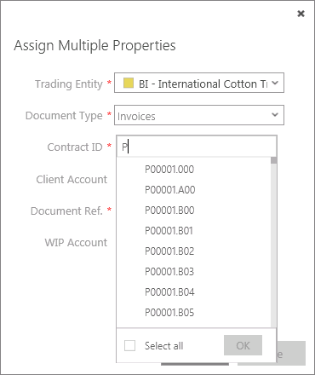

This works by filtering further as more data is keyed in.

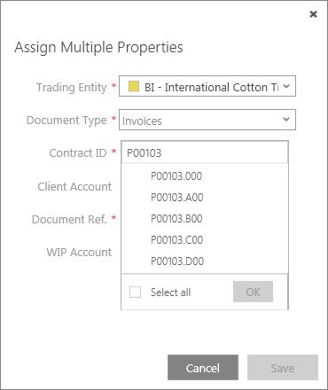

Select an index from the drop down by placing a tick the relevant checkbox.

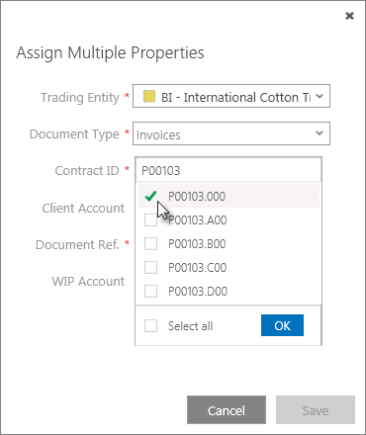

Click to confirm the selection.

Once all of the required indexes have been assigned click and the documents will be uploaded to DOCMAN.

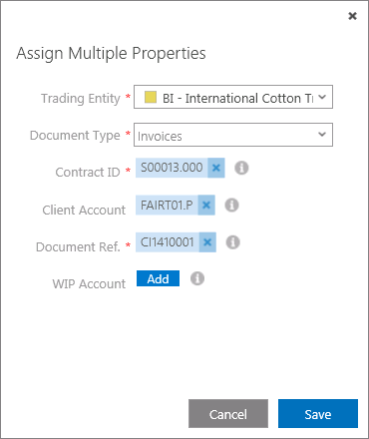

To add a Doc. Type to multiple documents with the same

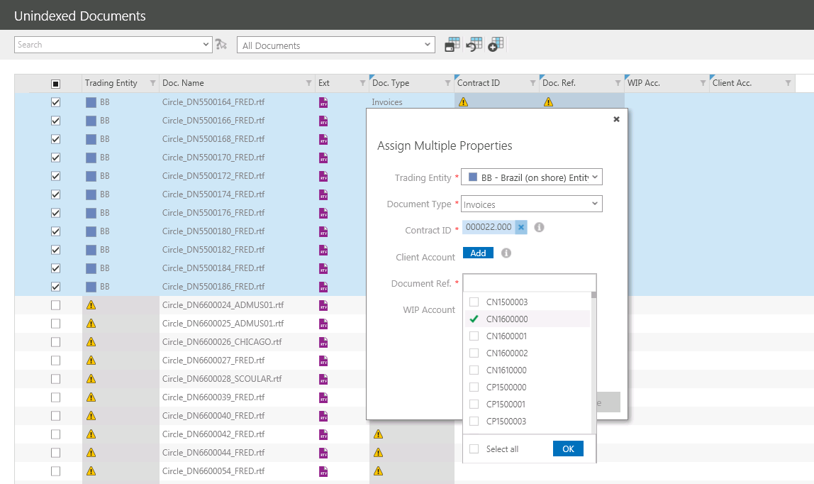

All documents will now be assigned to the selected Doc. Type.

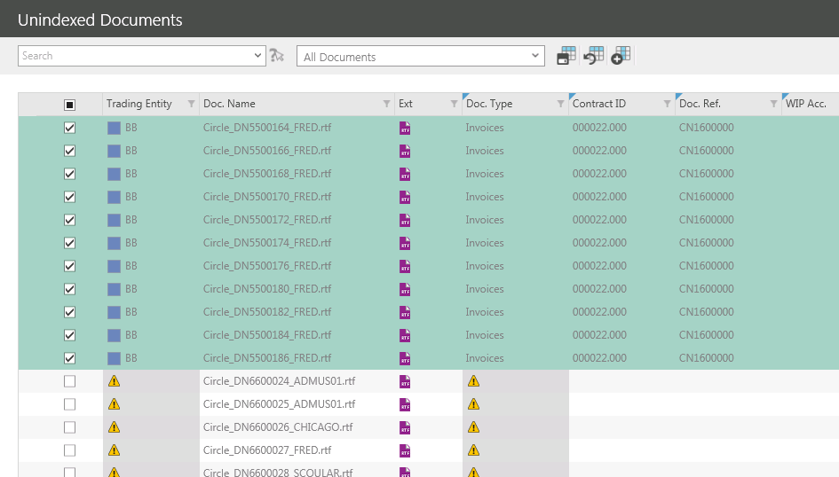

Once the indexes applied to a document meet the minimum requirements set out in the conditional mandatory rules it will automatically be moved from the DroppedFiles folder and placed in the appropriate folder within comp.

To indicate that a document has been sufficiently indexed the green tick will appear next to the document.

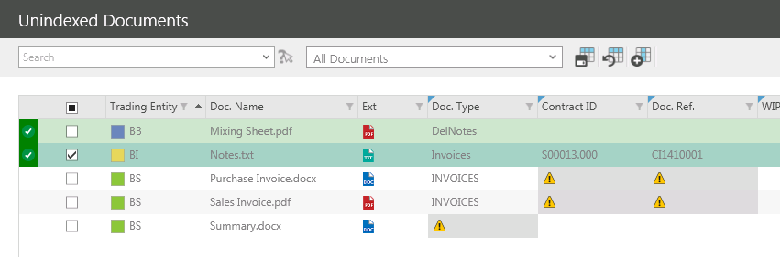

A pop up message will also appear in the bottom right hand corner of the screen with details of any documents that have been indexed too.

Details in the message include which DOCMAN folder the document was moved to:

Trading Entity\Document Type\Document Name

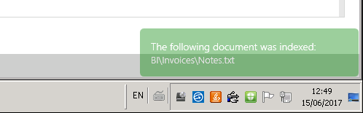

Once indexed, documents will be visible in the Company Documents screen.

Click to refresh the document list and remove any indexed documents from the Unindexed Documents screen.

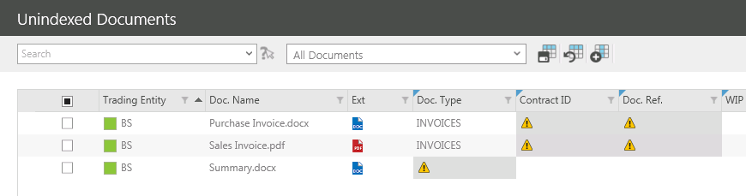

DOCUMENT SEARCHING
DOCMAN contains a search field that enables users to search for documents by any of the information displayed on the document grid. This means that any search criteria used will be referenced against the Trading Entity, Document Name, Doc. Type etc.

Search criteria can also be used to form filters that can be used again in the future should the same search be required.

To search for a document, place the cursor in the Search field at the top of the screen and enter the search criteria to activate the predictive search function.

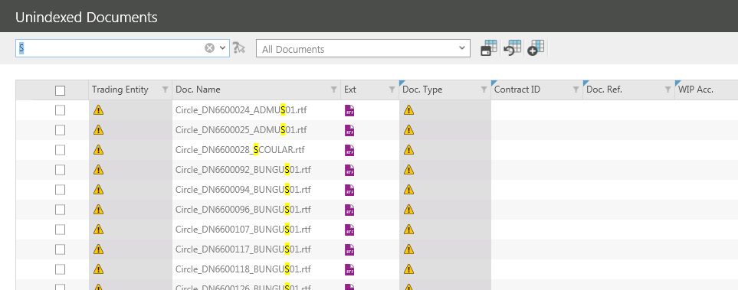

Documents that contain the criteria entered will remain visible in the unindexed documents screen with the criteria searched for highlighted in yellow.

Type more into the search field to filter the list further.

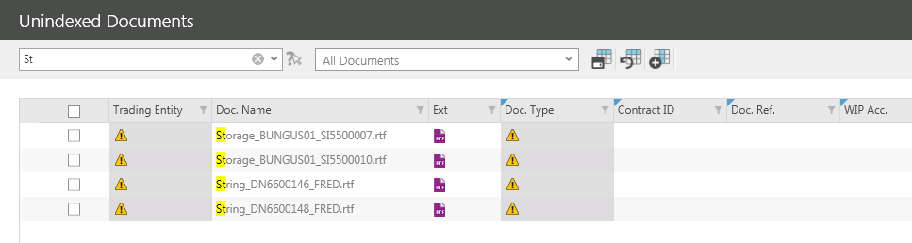

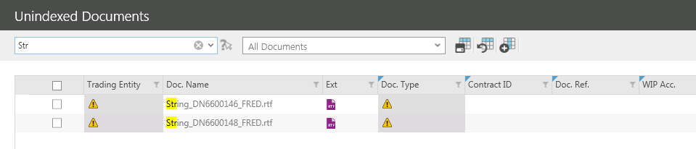

Once the filter has been entered, only the relevant documents will be displayed.
SAVING DOCUMENT SEARCHES
To save the search criteria to a filter for future use click and the following pop out should appear:

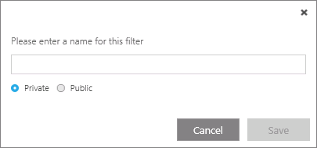

Give the new filter a name.

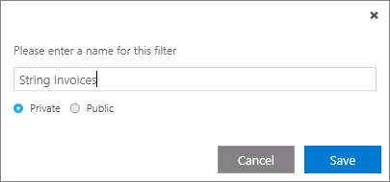

Filters can be kept private or made public so that other users can use it too. Choose an option by clicking the relevant radio button.

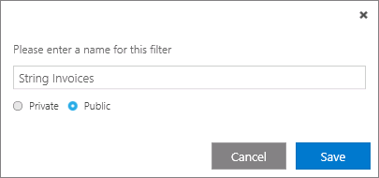

To save the new filter click .

The filter can now be selected from the drop down list in the top of the screen.

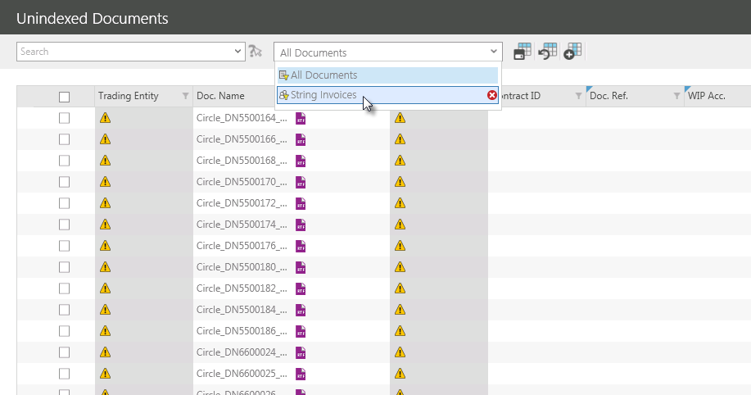

Once selected, the filter will be applied and only the relevant documents will be displayed.

SORTING THE DOCUMENT LIST
Use the Column Headers to determine the order in which documents that appear in the list are displayed.

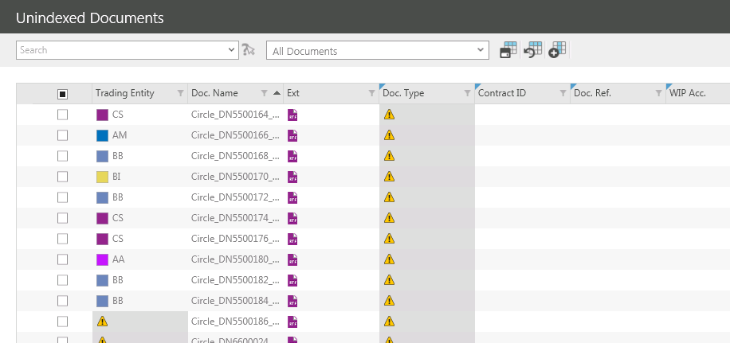

Clicking on the Trading Entity column heading sorted the documents into descending alphabetical order.

This is indicated by the downward facing arrow now visible on the column heading .

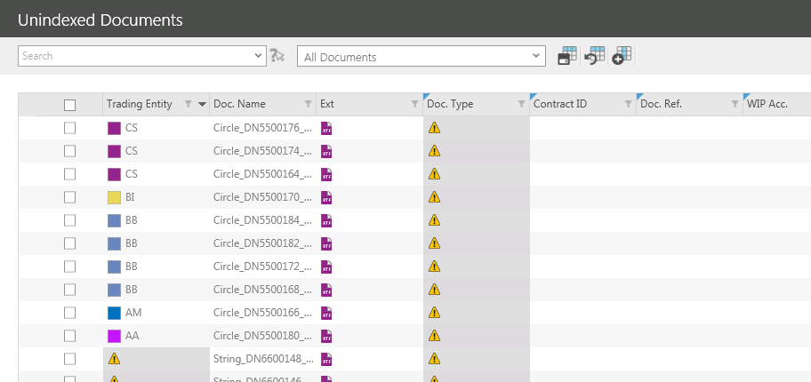

To reverse the order documents appear, click on the same column heading again.

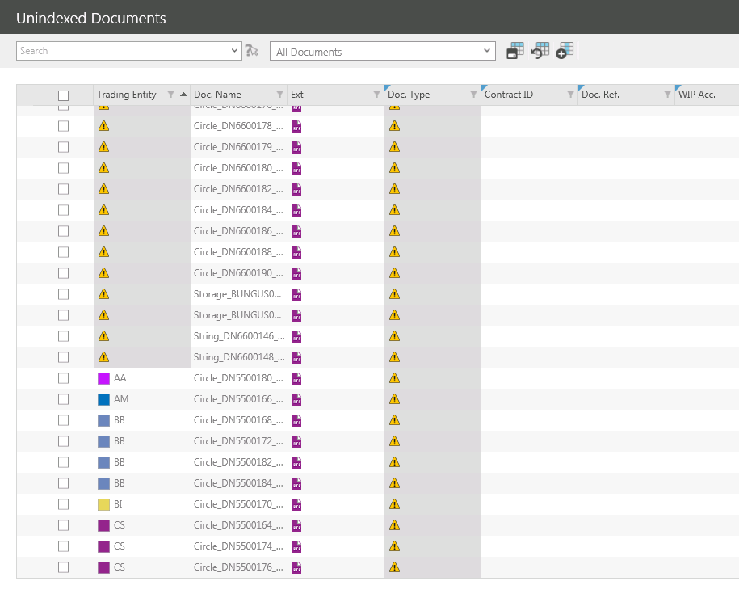

This is indicated by the upward facing arrow now visible on the column heading .

FILTERING THE DOCUMENT LIST
Column Heading Filters can be used to display only the documents that meet the specified criteria and hide those that do not.

To filter documents click on the in the relevant column heading.

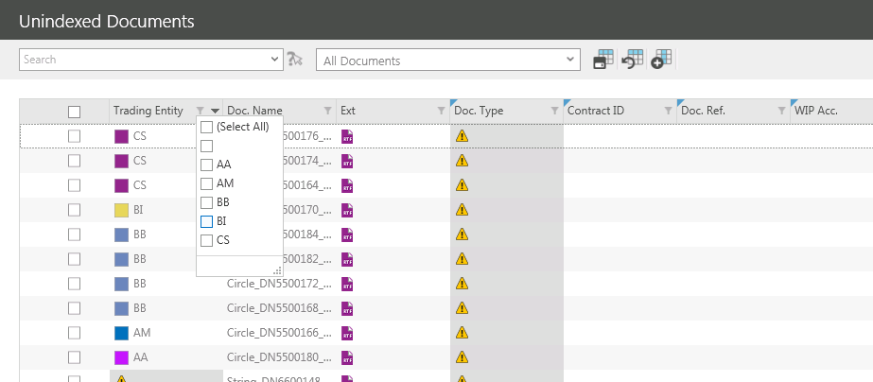

From the dropdown that appears select the required filter by placing a tick in the corresponding box.

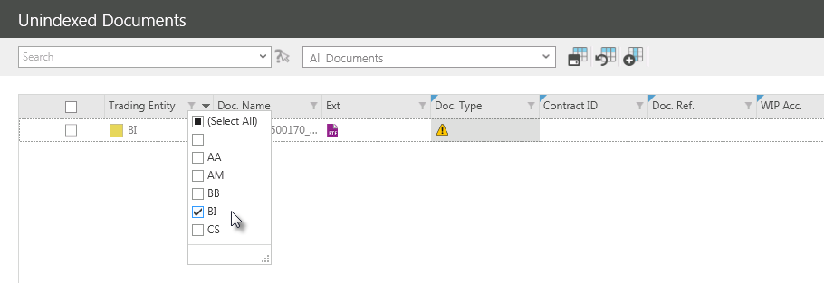

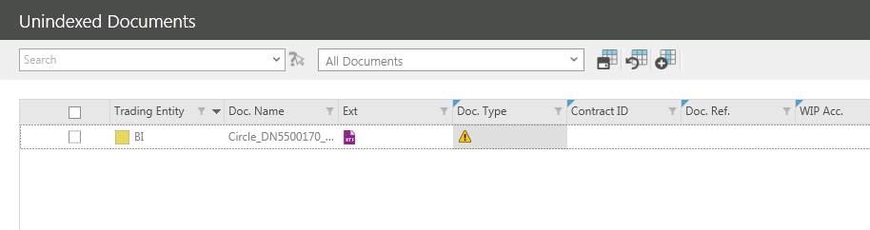

The applied filter can be seen along with the document count in the bottom left hand corner of the screen.

The filter can be removed by unticking the check box and reinstated by replacing it.

Edit the filter by clicking on the in the same column heading again.

Add additional filters by ticking the relevant tick boxes.

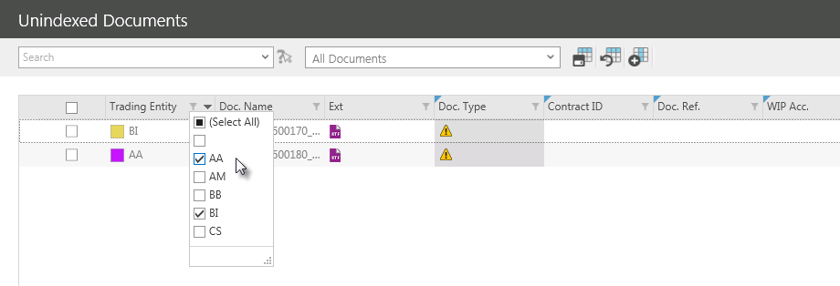

The additional filter will now also be visible at the bottom of the screen.

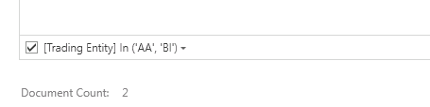

Documents can be hidden by removing the ticks from the relevant tick boxes.

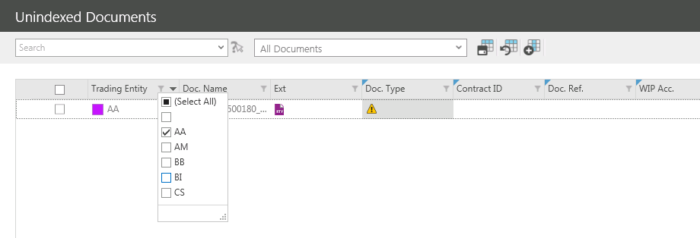

Filters can be combined to further reduce the list of documents. Select a filter from the first column required.

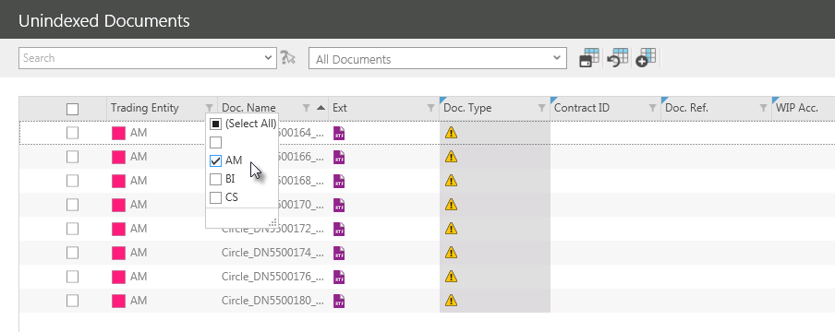

Then select a filter from additional columns.

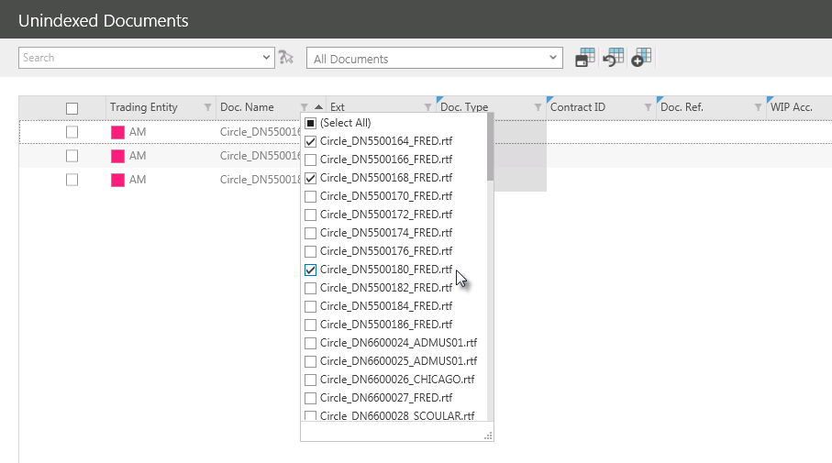

ADVANCED FILTERING
Once a filter has been added the advanced filtering options can be used to apply more complex filter criteria.

The applied filter can be seen along with the document count in the bottom left hand corner of the screen.

To access the advanced filtering options click in the bottom right hand corner of the screen.

The Filter Editor will be displayed.

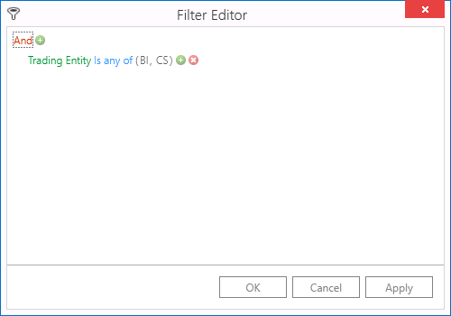

Clicking different elements of the displayed filter will enable the filter to be changed or additional criteria to be added.

FILTER LOGIC
Click And to change the filter logic.

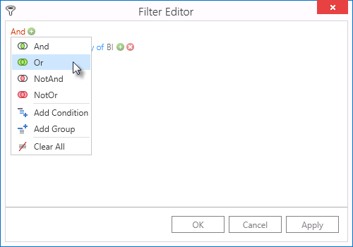

The filter logic can be changed to include:

- And - Filters entries that contain all the search terms entered. This normally returns fewer results than searching for a term on its own.
- Or – Filters all entries containing one or more of the search terms entered. This also returns more entries than searching for a term on its own.
NotAnd - Filters entries that do not contain all the search terms entered. This normally returns fewer results than searching for a term on its own.
- NotOr – Filters all entries that do not contain one or more of the search terms entered. This also returns more entries than searching for a term on its own.
Additional filter criteria can be added:

- Add Condition – Enables the addition of further filter criteria (columns)
- Add Group – Enables the addition of multiple filter condition groups. A filter condition group is a set of criteria combined by the same logical operator. This type of filter will return two separate sets of results.
- Clear All – Can be used to clear all filters.

OPERATORS
Click on the data column to change the filter criteria.

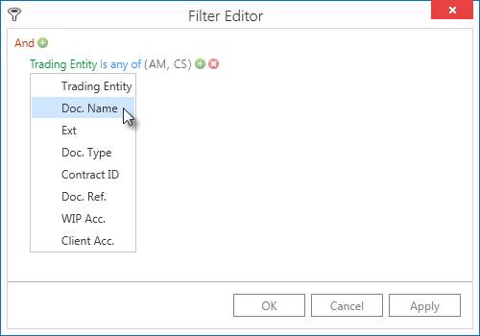

Click on the comparison operator to change the filter criteria.

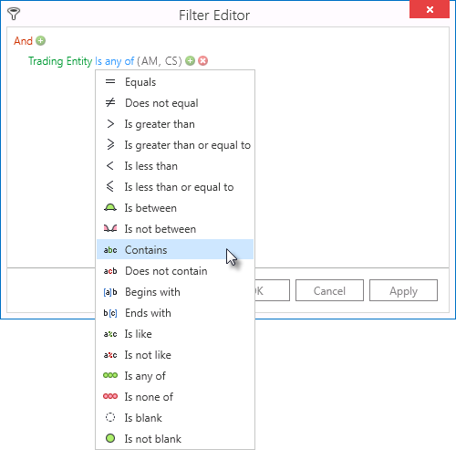

The comparison operator can be changed to include:

- Equals - Filters entries that contain all search terms entered.
- Does not equal - Filters entries that do not contain all search terms entered.
- Is greater than - Filters entries that contain a higher value than the search terms entered
- Is greater than or equal to - Filters entries that contain a higher value or is equal to than the search terms entered.
- Is less than - Filters entries that contain a lower value than the search terms entered.
- Is less than or equal to - Filters entries that contain a lower value or is equal to than the search terms entered.
- Is between - Filters entries that contain a value between two search terms entered.
- Is not between - Filters entries that do not contain a value between two search terms entered.
- Contains - Filters entries that contain the text entered.
- Does not contain - Filters entries that do not contain the text entered.
- Begins with - Filters entries that begin with the text entered.
- Ends with - Filters entries that end with the text entered.
- Is like - Filters entries that are similar to the text entered.
- Is not like - Filters entries that are not similar to the text entered.
- Is any of - Filters entries that contain at least one search terms entered.
- Is none of - Filters entries that do not contain at least one search terms entered.
- Is blank - Filters entries that contain no search terms.
- Is not blank - Filters entries that contain any search terms.

To add additional criteria to an existing condition click .

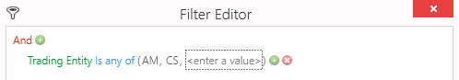

Enter in the additional filter value.

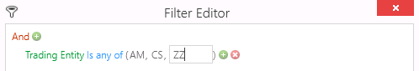

To remove an existing condition click

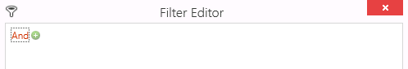

To see the changes reflected in the document list click .
Previously applied filters can be selected from a dropdown list by clicking on the filter displayed in the bottom left hand corner of the screen.

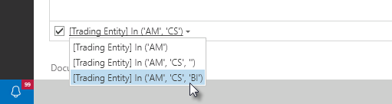

Delete the filter by clicking in the bottom right hand corner of the screen.

SAVING FILTERS FOR FUTURE USE
Once a filter has been applied to the list of Unindexed Documents it can be saved to be used again in the future, either by the user who created it or by all ITAS users.

Once a filter has applied, click and the following screen will appear:

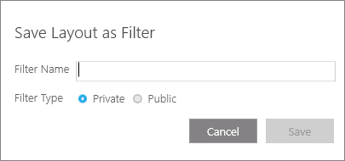

Enter a Filter Name.

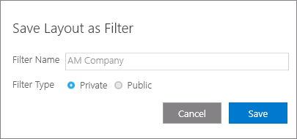

Filters can be kept private or made public so that other users can use it too. Choose an option by clicking the relevant radio button.

Click to save the filter.

APPLYING A SAVED FILTER
Once a filter has been saved it can be applied by selecting it from the Filter dropdown list at the top of the screen.

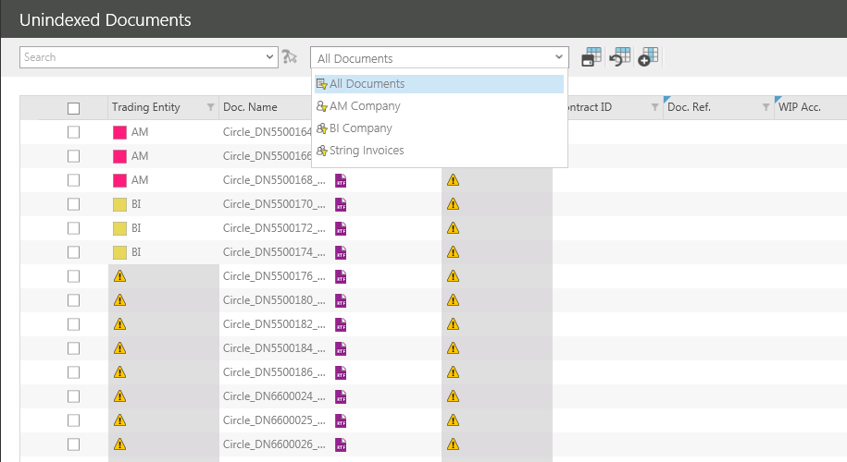

Select a private filter with this marker .

Select a public filter with this marker .

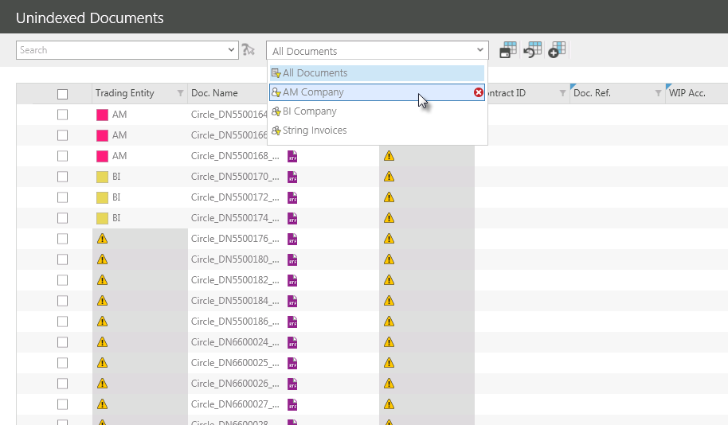

Company Documents
Company Documents will display a list of all indexed documents that have been uploaded to ITAS.

This screen enables users to view, edit, print and email documents

LAUNCHING COMPANY DOCUMENTS
To launch the DOCMAN Menu click in the Navigation Panel.

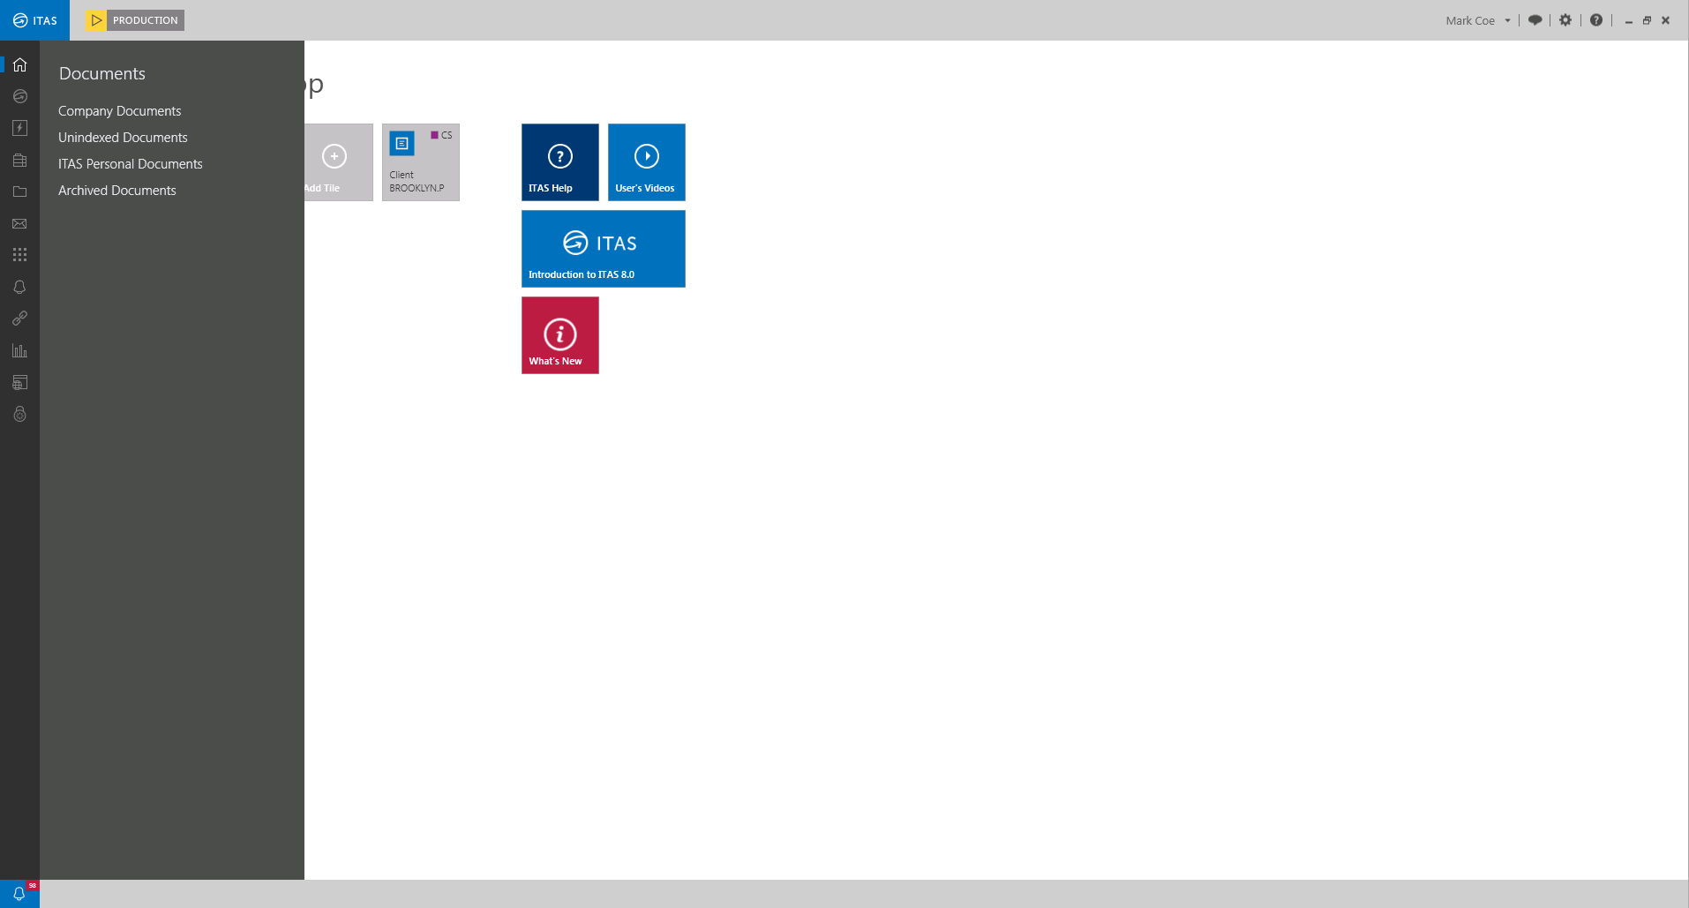

Click to view a list of unindexed documents.

DOCUMENT SEARCHING
DOCMAN contains a search field that enables users to search for documents by any of the information displayed on the document grid. This means that any search criteria used will be referenced against the Trading Entity, Document Name, Doc. Type etc.

Search criteria can also be used to form filters that can be used again in the future should the same search be required.

To search for a document, place the cursor in the Search field at the top of the screen and enter the search criteria to activate the predictive search function.

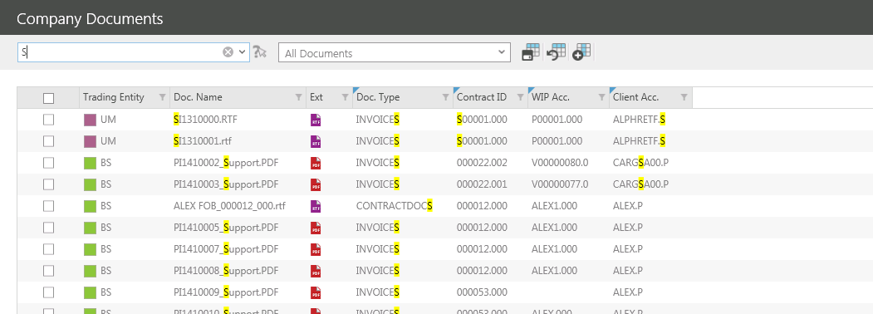

Documents that contain the criteria entered will remain visible in the unindexed documents screen with the criteria searched for highlighted in yellow.

Type more into the search field to filter the list further.

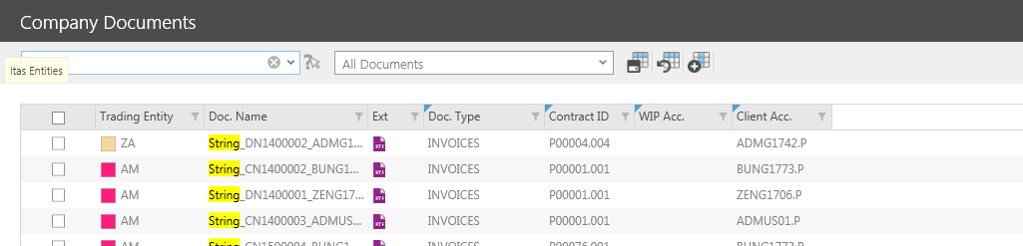

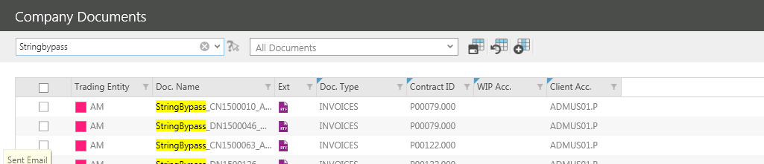

Once the filter has been entered, only the relevant documents will be displayed.

SAVING DOCUMENT SEARCHES
To save the search criteria to a filter for future use click and the following pop out should appear:

Give the new filter a name.

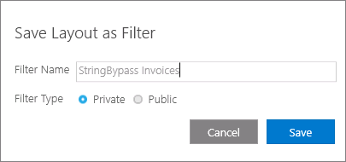

Filters can be kept private or made public so that other users can use it too. Choose an option by clicking the relevant radio button.

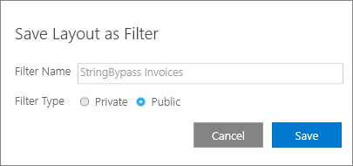

To save the new filter click .

The filter can now be selected from the drop down list in the top of the screen.

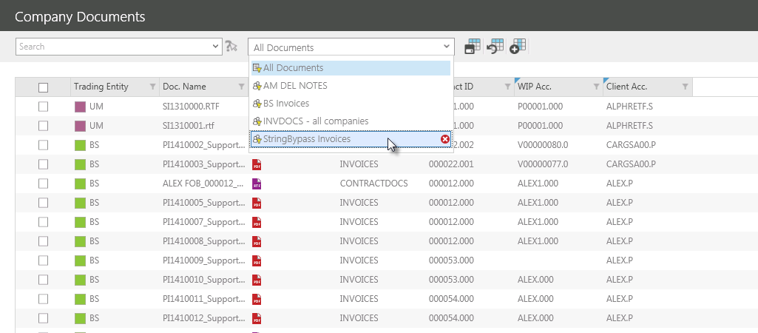

Once selected, the filter will be applied and only the relevant documents will be displayed.

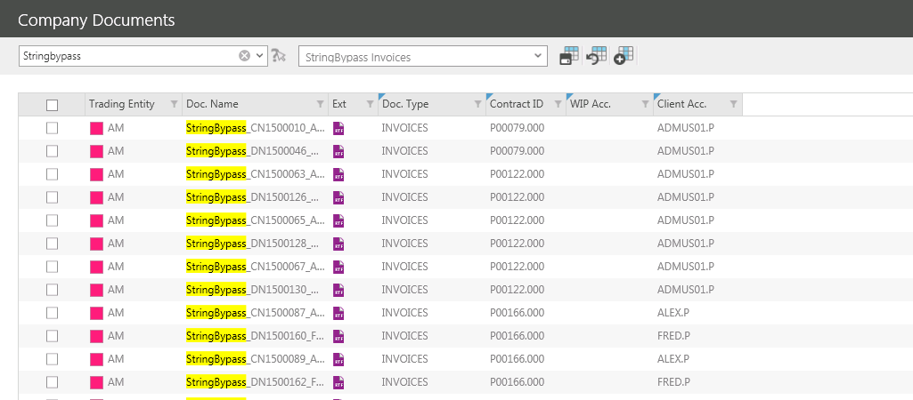

SORTING THE DOCUMENT LIST
Use the Column Headers to determine the order in which documents that appear in the list are displayed.

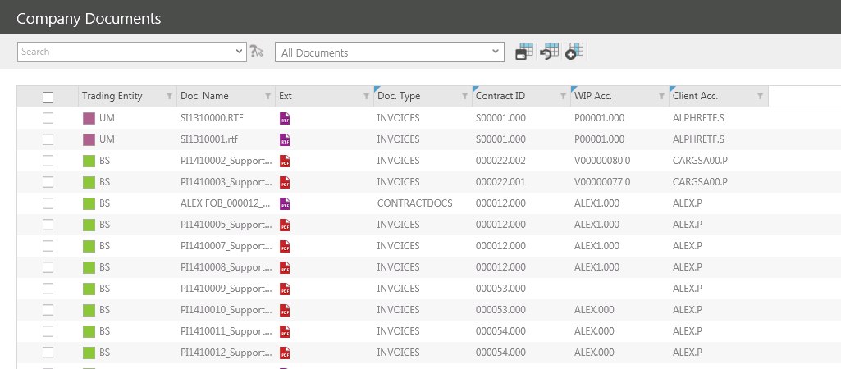

Clicking on the Trading Entity column heading sorted the documents into descending alphabetical order.

This is indicated by the downward facing arrow now visible on the column heading .

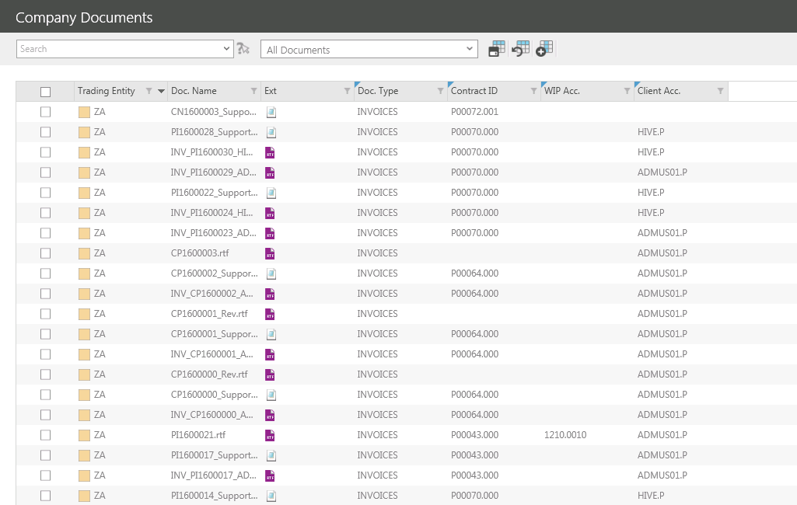

To reverse the order documents appear, click on the same column heading again.

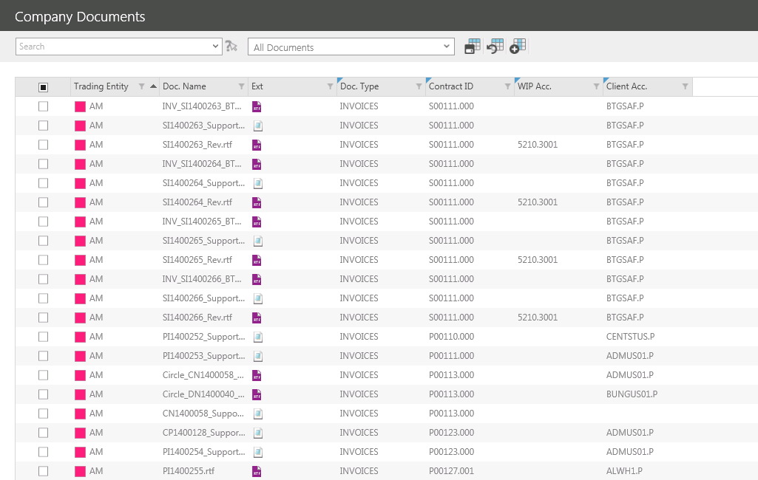

This is indicated by the upward facing arrow now visible on the column heading .

FILTERING THE DOCUMENT LIST
Column Heading Filters can be used to display only the documents that meet the specified criteria and hide those that do not.

To filter documents click on the in the relevant column heading.

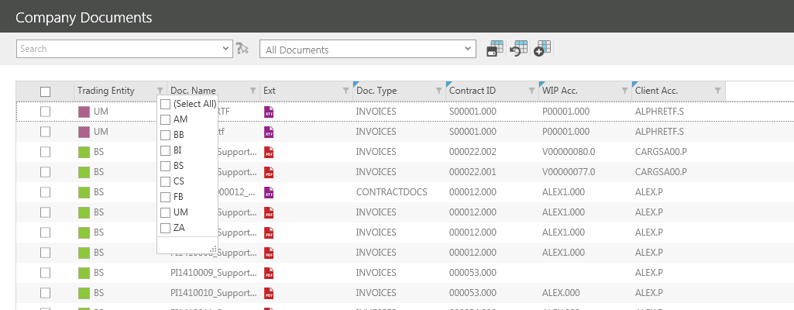

From the dropdown that appears select the required filter by placing a tick in the corresponding box.

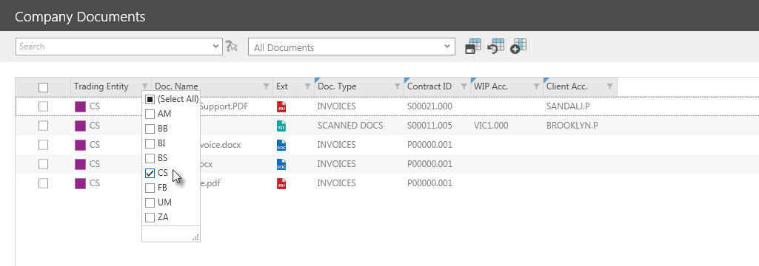

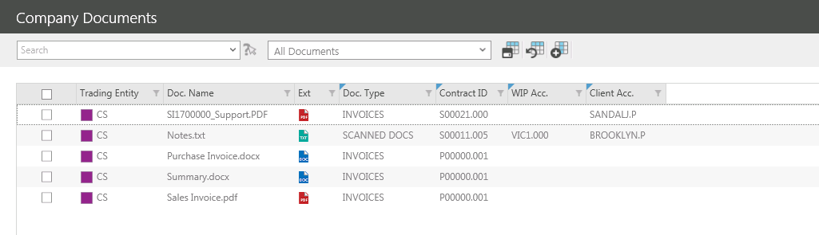

The applied filter can be seen along with the document count in the bottom left hand corner of the screen.

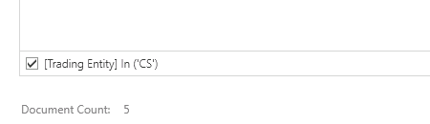

The filter can be removed by unticking the check box and reinstated by replacing it.

Edit the filter by clicking on the in the same column heading again.

Add additional filters by ticking the relevant tick boxes.

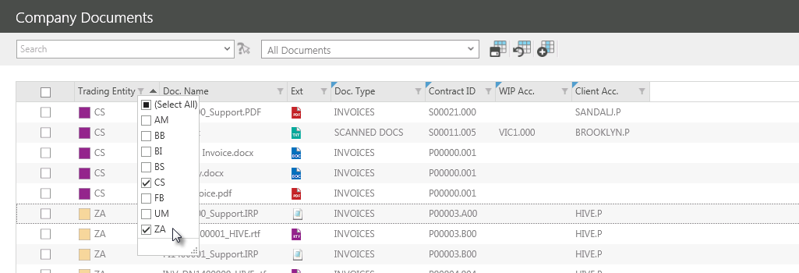

The additional filter will now also be visible at the bottom of the screen.

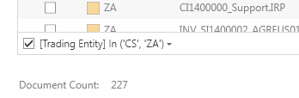

Documents can be hidden by removing the ticks from the relevant tick boxes.

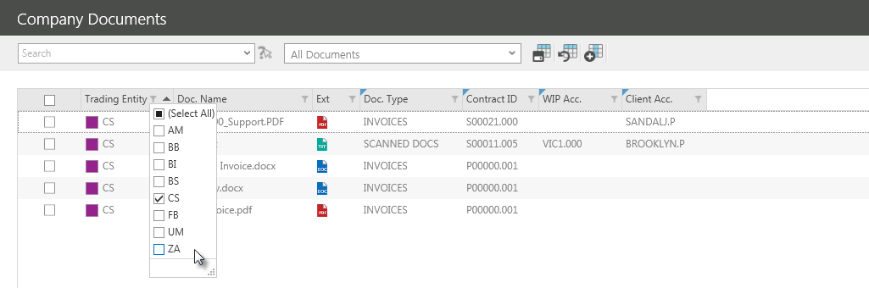
Filters can be combined to further reduce the list of documents. Select a filter from the first column required.

Then select a filter from additional columns.

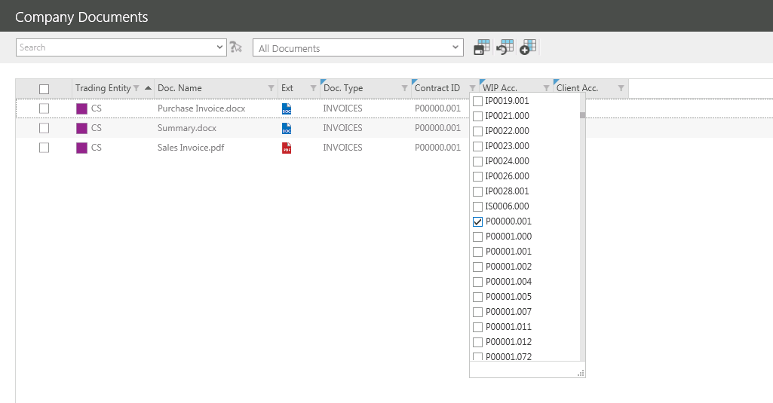

ADDING COLUMNS
Users can add additional columns for that can also searching, filtering and sorting.

To add a new column click on or right click on an existing column header to launch the right click menu and select Show Column Chooser.

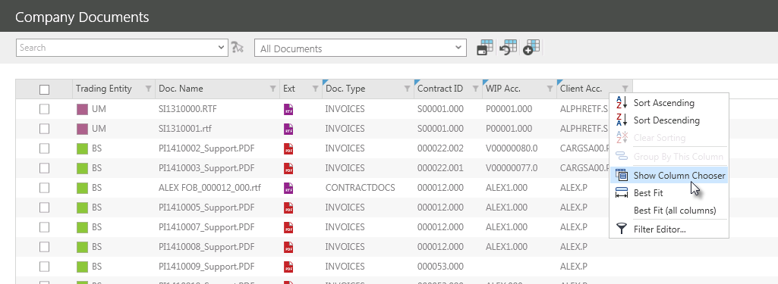

The Show Column Choose screen should appear:

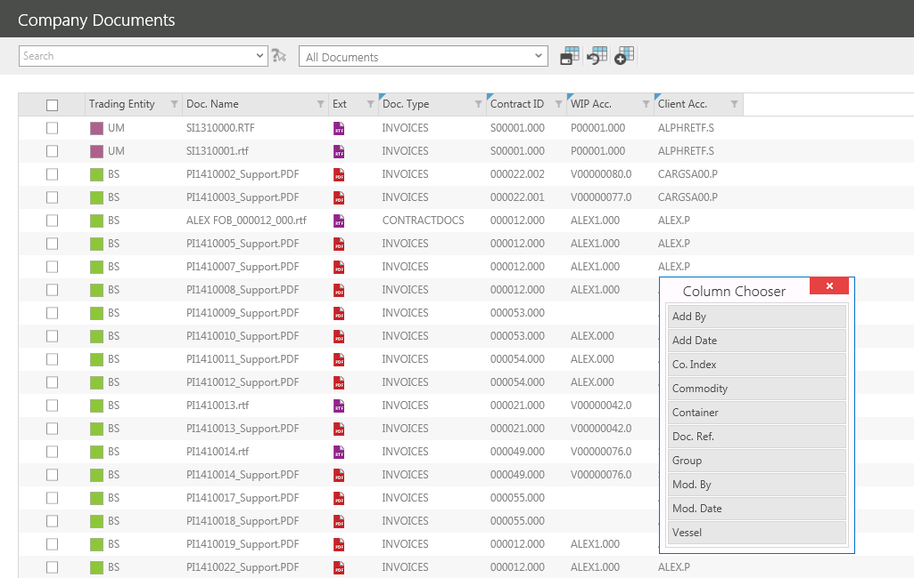

Double click on a column in the Column chooser screen to add it to the document list.

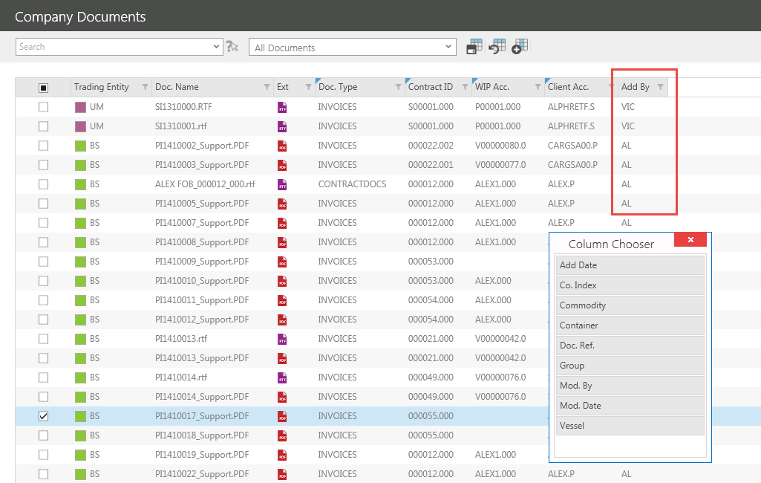

Alternatively new columns can be dragged to a preferred position.

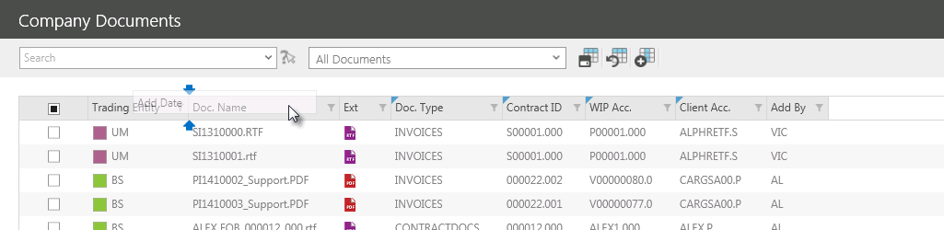

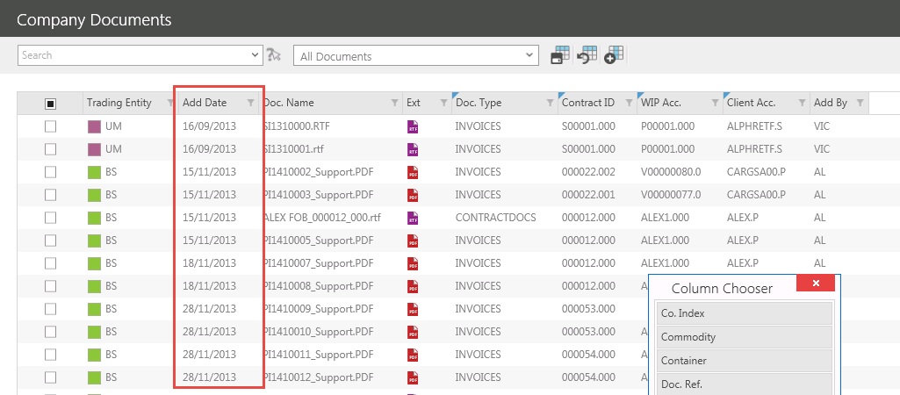
REORDERING COLUMNS
Columns can be reordered by dragging them to the preferred position on the document grid.

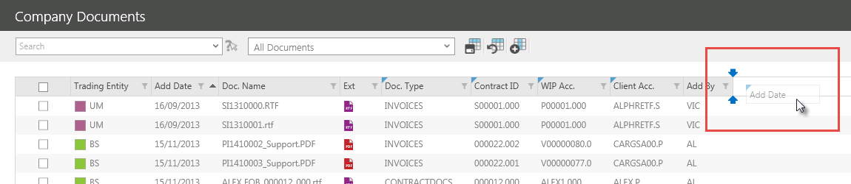

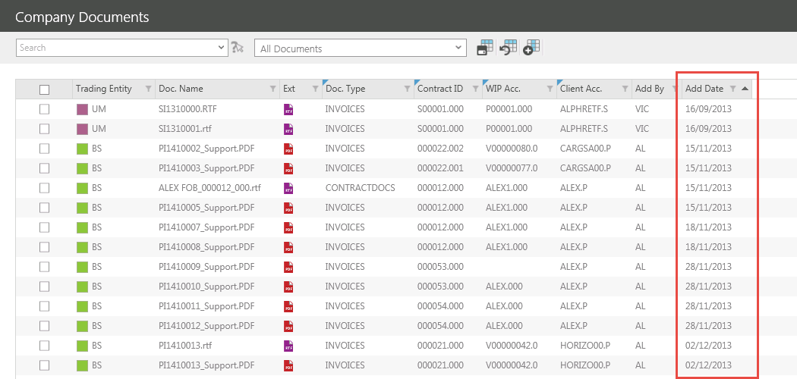
FILTERING BY DATE
To filter documents by date click on in the relevant column heading.

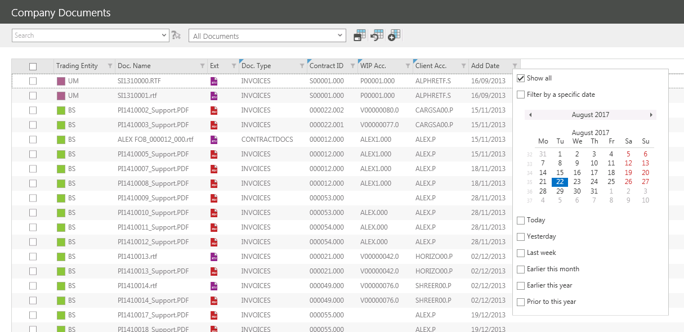

The following screen should appear:

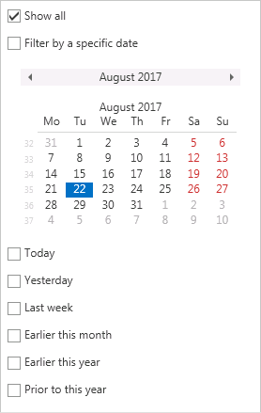
There are several date filter options that can be selected:

- Show all – Displays all documents
- Filter by a specific date – Filters documents that were added to DOCMAN on the selected date.

The following filters are dynamic which means when added to a filter that is saved for future use it will use the current date for Today and not the date the filter was created:

- Today - Filters documents that were added today.
- Yesterday - Filters documents that were added today.
- Last week - Filters documents that were added today.
- Earlier this month - Filters documents that were added today.
- Earlier this year - Filters documents that were added today.
- Prior to this year - Filters documents that were added today.

To select a filter, tick the relevant check box.

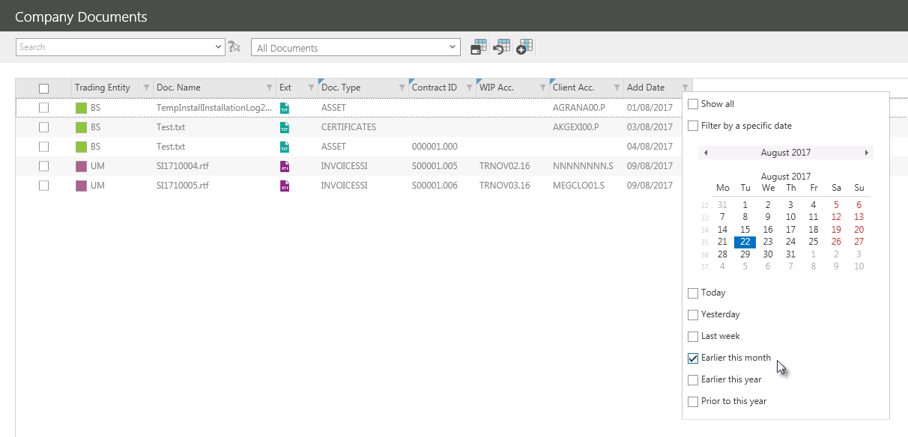

Tick multiple boxes to combine filters.

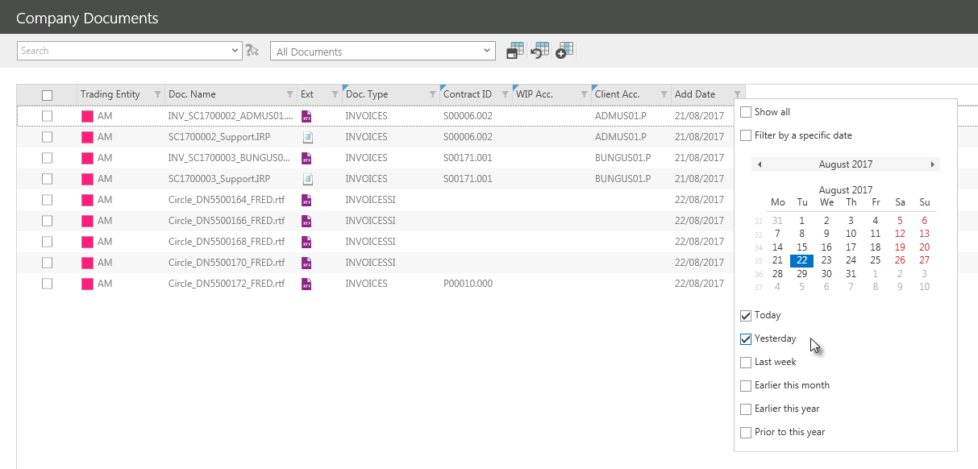

To select a specific date, tick Filter by a specific date and then click on the relevant date.

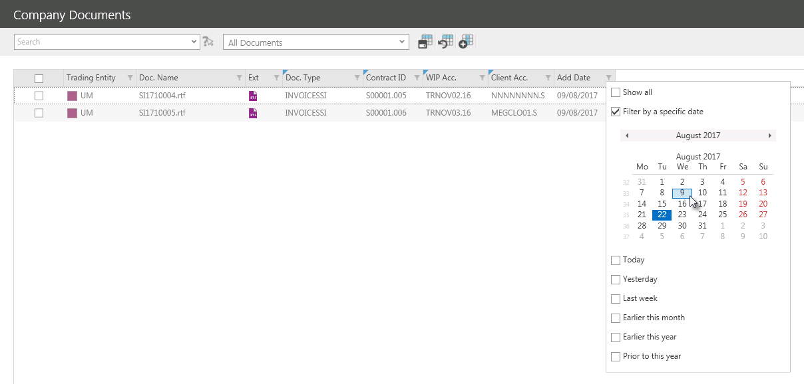

ADVANCED FILTERING
Once a filter has been added the advanced filtering options can be used to apply more complex filter criteria.

The applied filter can be seen along with the document count in the bottom left hand corner of the screen.

To access the advanced filtering options click in the bottom right hand corner of the screen.

The Filter Editor will be displayed.

Clicking different elements of the displayed filter will enable the filter to be changed or additional criteria to be added.

FILTER LOGIC
Click And to change the filter logic.

The filter logic can be changed to include:

- And - Filters entries that contain all the search terms entered. This normally returns fewer results than searching for a term on its own.
- Or – Filters all entries containing one or more of the search terms entered. This also returns more entries than searching for a term on its own.
NotAnd - Filters entries that do not contain all the search terms entered. This normally returns fewer results than searching for a term on its own.
- NotOr – Filters all entries that do not contain one or more of the search terms entered. This also returns more entries than searching for a term on its own.
Additional filter criteria can be added:

- Add Condition – Enables the addition of further filter criteria (columns)
- Add Group – Enables the addition of multiple filter condition groups. A filter condition group is a set of criteria combined by the same logical operator. This type of filter will return two separate sets of results.
- Clear All – Can be used to clear all filters.

OPERATORS
Click on the data column to change the filter criteria.

Click on the comparison operator to change the filter criteria.

The comparison operator can be changed to include:

- Equals - Filters entries that contain all search terms entered.
- Does not equal - Filters entries that do not contain all search terms entered.
- Is greater than - Filters entries that contain a higher value than the search terms entered
- Is greater than or equal to - Filters entries that contain a higher value or is equal to than the search terms entered.
- Is less than - Filters entries that contain a lower value than the search terms entered.
- Is less than or equal to - Filters entries that contain a lower value or is equal to than the search terms entered.
- Is between - Filters entries that contain a value between two search terms entered.
- Is not between - Filters entries that do not contain a value between two search terms entered.
- Contains - Filters entries that contain the text entered.
- Does not contain - Filters entries that do not contain the text entered.
- Begins with - Filters entries that begin with the text entered.
- Ends with - Filters entries that end with the text entered.
- Is like - Filters entries that are similar to the text entered.
- Is not like - Filters entries that are not similar to the text entered.
- Is any of - Filters entries that contain at least one search terms entered.
- Is none of - Filters entries that do not contain at least one search terms entered.
- Is blank - Filters entries that contain no search terms.
- Is not blank - Filters entries that contain any search terms.

To add additional criteria to an existing condition click .

Enter in the additional filter value.

To remove an existing condition click

To see the changes reflected in the document list click .

Previously applied filters can be selected from a dropdown list by clicking on the filter displayed in the bottom left hand corner of the screen.

Delete the filter by clicking in the bottom right hand corner of the screen.

SAVING FILTERS FOR FUTURE USE
Once a filter has been applied to the list of Unindexed Documents it can be saved to be used again in the future, either by the user who created it or by all ITAS users.

Once a filter has applied, click and the following screen will appear:

Enter a Filter Name.

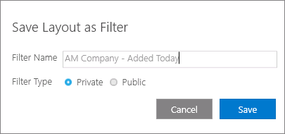

Filters can be kept private or made public so that other users can use it too. Choose an option by clicking the relevant radio button.

Click to save the filter.

APPLYING A SAVED FILTER
Once a filter has been saved it can be applied by selecting it from the Filter dropdown list at the top of the screen.

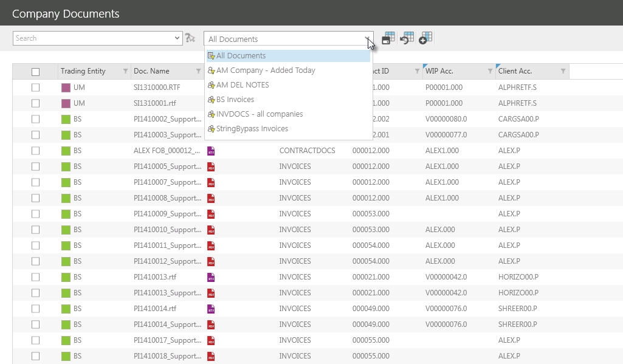

Select a private filter with this marker .

Select a public filter with this marker .

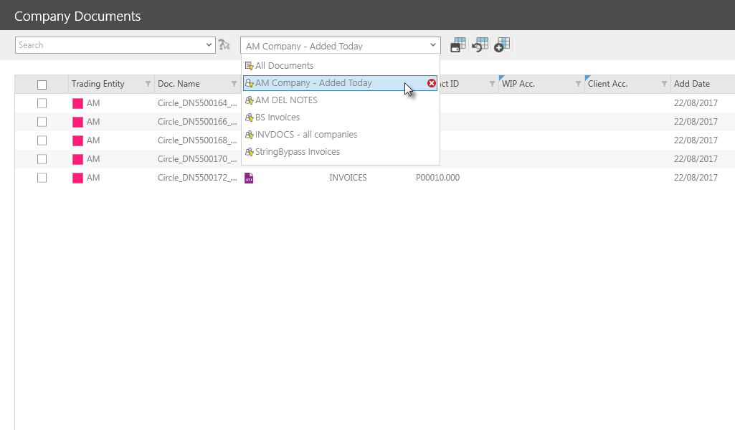
EDITING DOCUMENTS
Once saved to DOCMAN documents can be edited.

To edit the contents of a document, right click the relevant document to launch the right click menu.

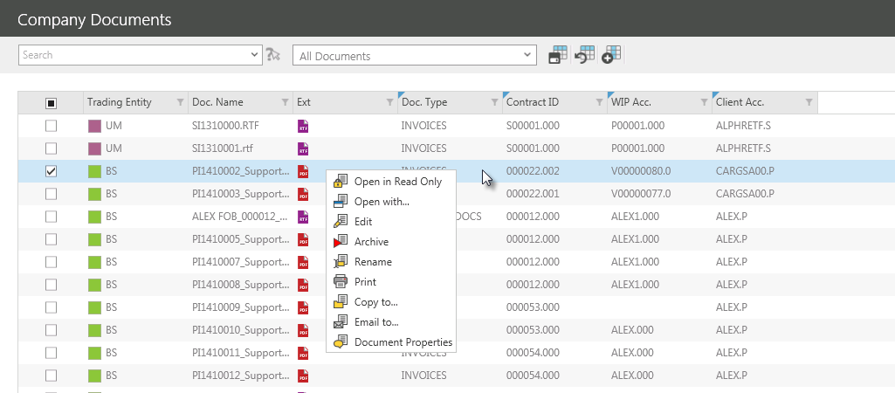

Select Edit to open the document.

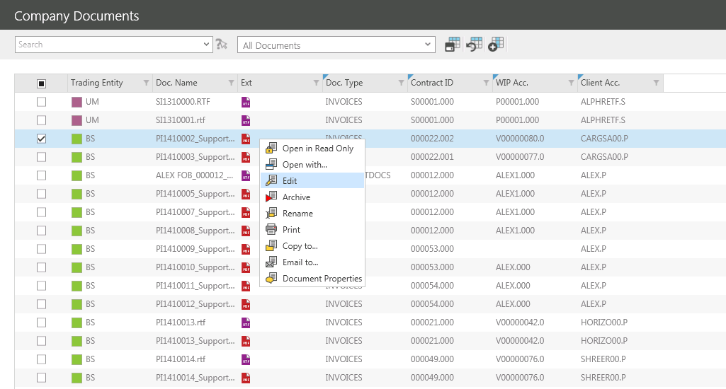
Alternatively select Open with… to select which application to open the document with.

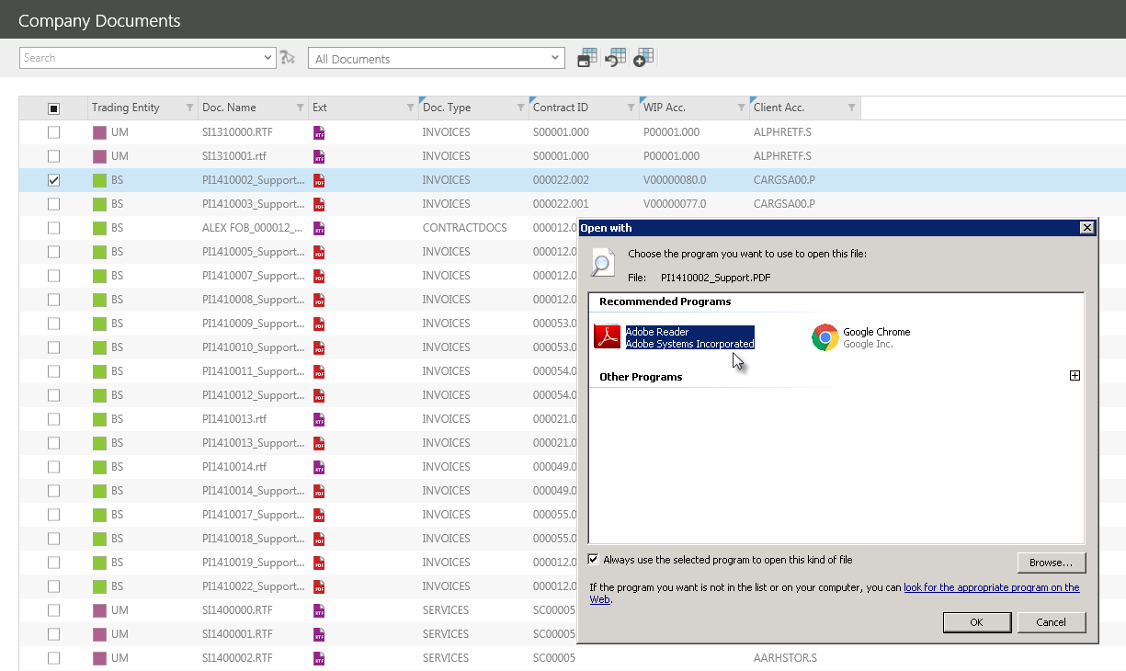

DOCUMENT PROPERTIES
To edit a documents properties, including the indexes assigned to it, right click the relevant document to launch the right click menu.

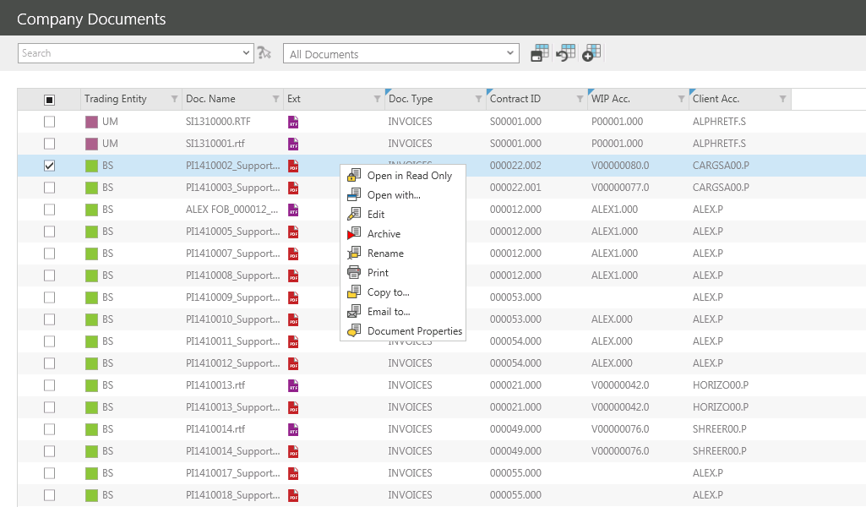

Select Document Properties to launch the document properties screen.

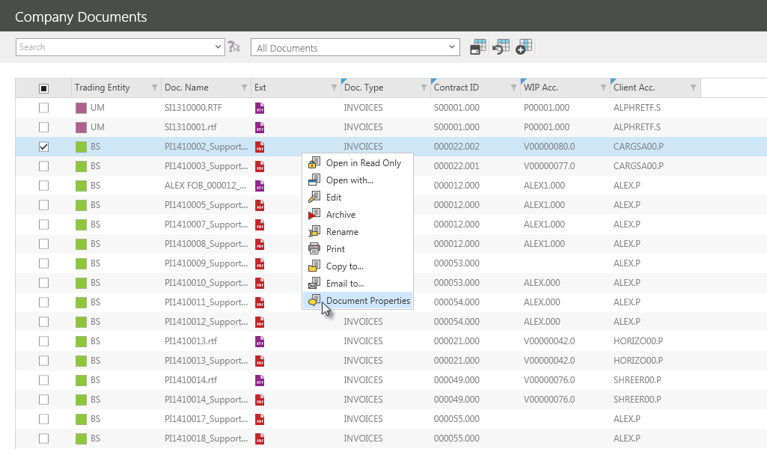

The following screen should appear:

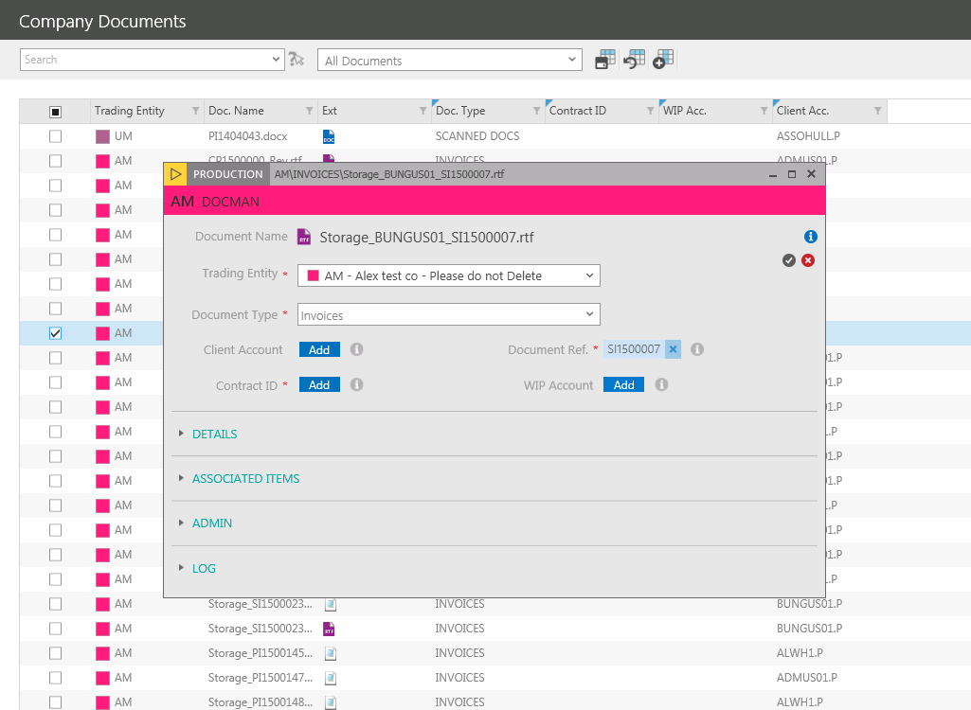

To edit the indexes in the main section of the Document Properties screen click Edit.

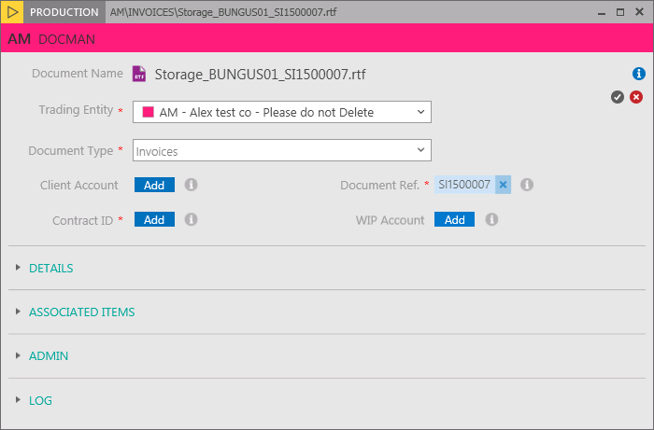

Select a different Trading Entity or Document Type from the dropdown lists.

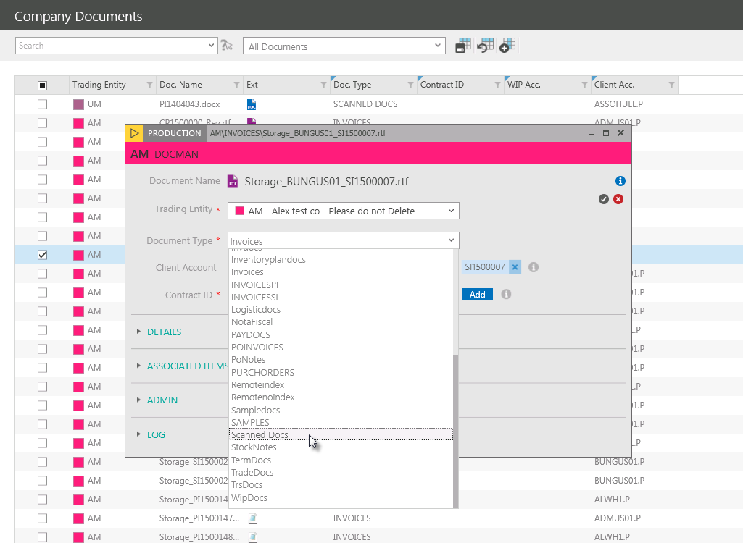

CONDITIONAL MANDATORY
The Document Type field employs the use of conditional mandatory rules, this means that any of the four indexes below, Contract ID. Client Account, Document Ref. or WIP Account may become mandatory depending on the Document Type chosen. Mandatory fields are highlighted with a .

For example, if the Invoices Document Type is selected then Contract ID and Document Ref. are mandatory and must be added to the document

But if the Scanned Documents option is selected none of the indexes become mandatory:

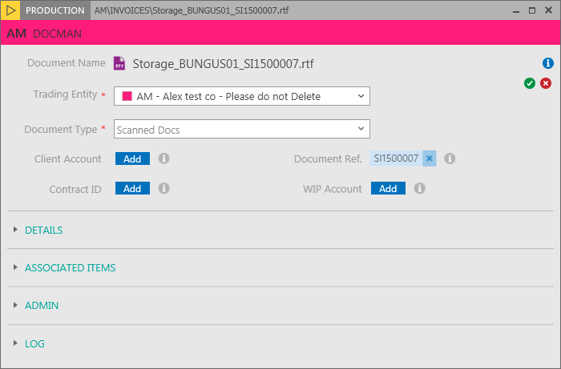

Conditional mandatory rules can be reconfigured to include whatever additional indexes if required. Contact Hivedome for assistance.

To add additional indexes click next the appropriate Index.

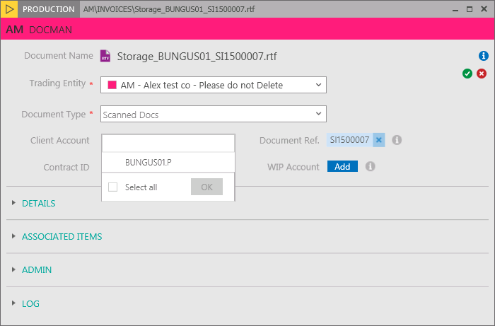

Scroll down the list and choose an index from the drop down by placing a tick the relevant checkbox.

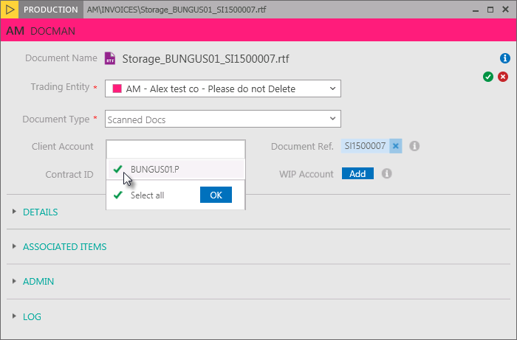

Click to confirm the selection.

These fields also have search fields that can be used to filter out specific indexes.
To search for an index click and place the cursor in the field at the top of the drop down list and begin typing in the search criteria to activate the predictive search function.

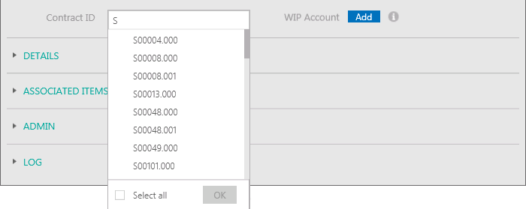

This works by filtering further as more data is keyed in.

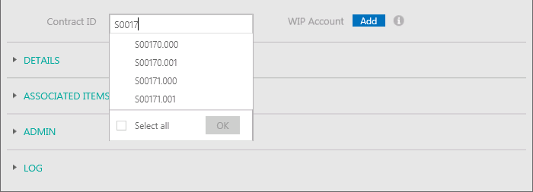

Select an index from the drop down by placing a tick the relevant checkbox.

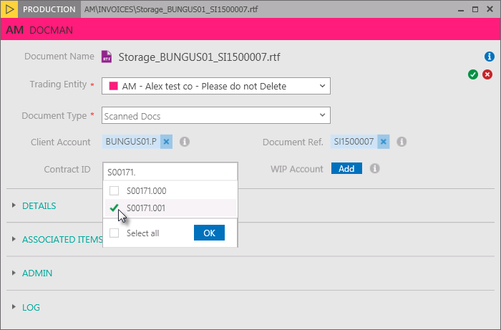

Click to confirm the selection.

Once all indexes have been added, click .

To edit the DETAILS or ASSOCIATED ITEMS click to expand the relevant section.

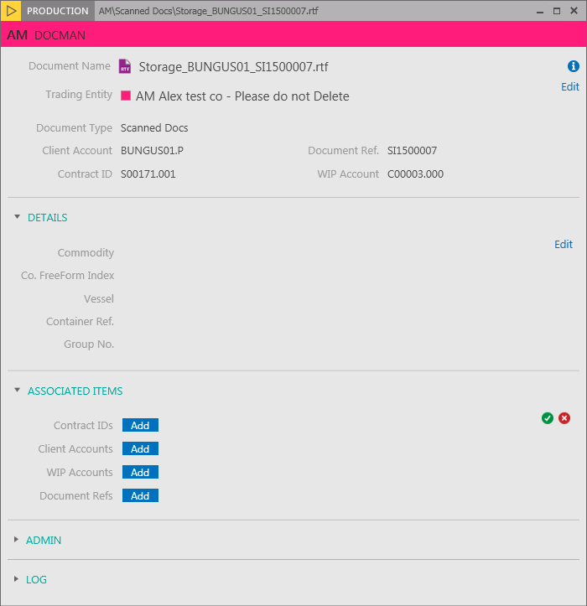

To edit the indexes in this section click Edit.

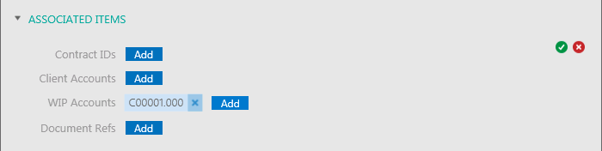

Once all indexes have been added, click .

To see the changes in the Company Documents grid click to close the Document Properties screen.

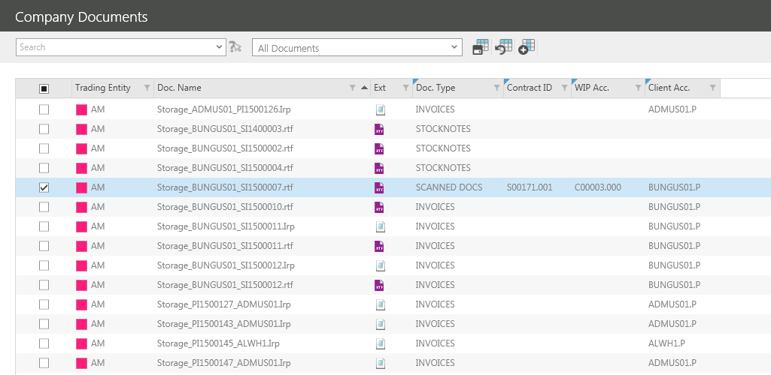

ARCHIVING DOCUMENTS
Company Documents can be archived which moves the document from its current Comp folder to an Old folder. For example, an invoice may be stored in the following Comp folder:

C:\comp\um\Invoices

Once archived it will be moved to this folder:

I:\comp\um\Invoices\Old

This means that the document will no longer be viewed in Company Documents but will be available in Archived Documents.

To archive a Company Document right click the relevant document.

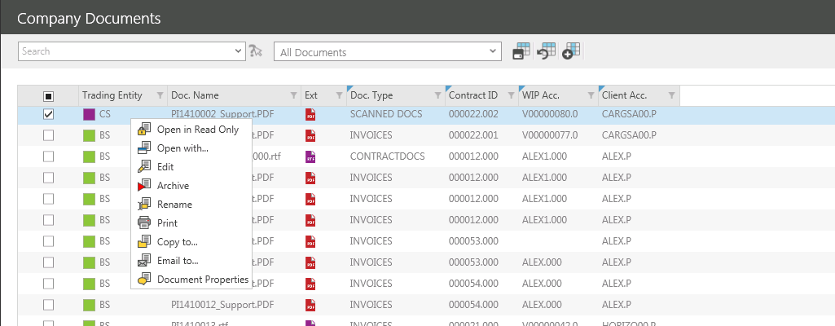

From the right click menu select Archive.

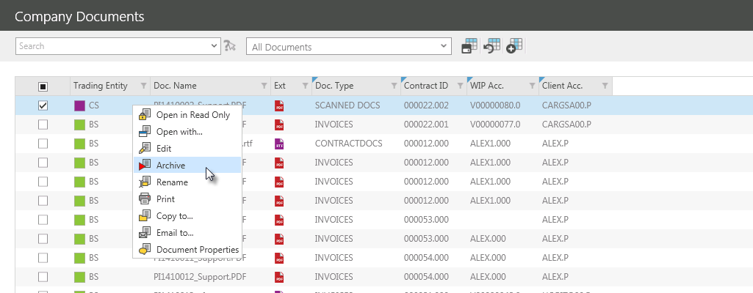

The following message should appear:

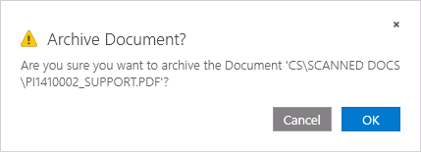

Click to continue, and the following message should appear:

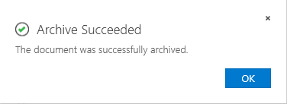

Click to continue.

The document will now no longer be visible in Company Documents, but it can be viewed in Archived Documents.

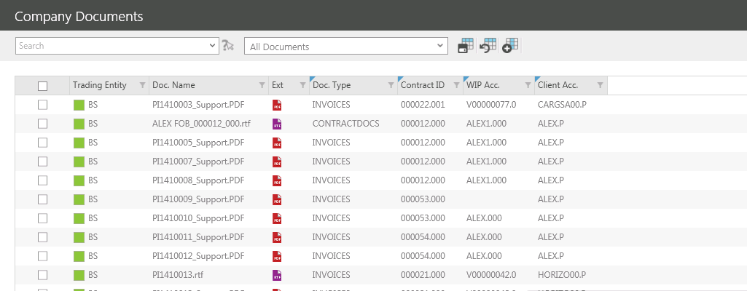
To archive a group of documents ensure the ticket box for each of the documents to be archived is ticketed.

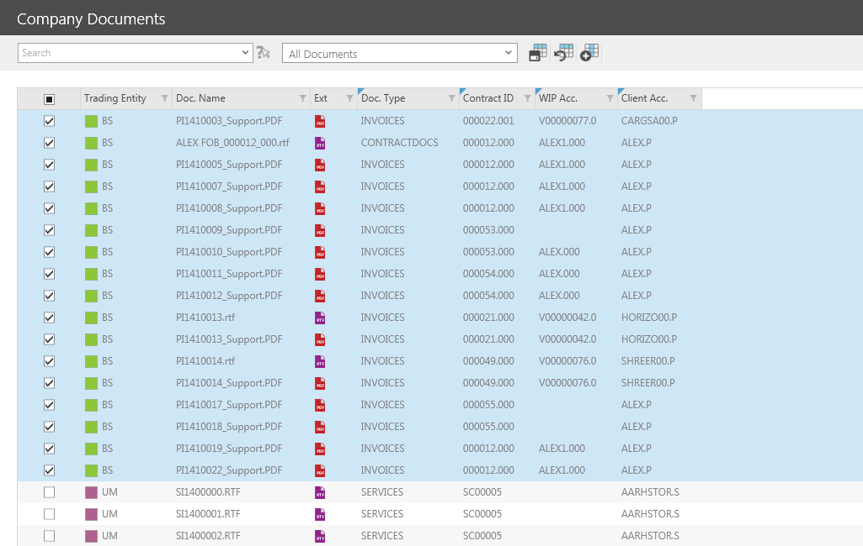

To archive the Company Documents, right click on the selected documents.

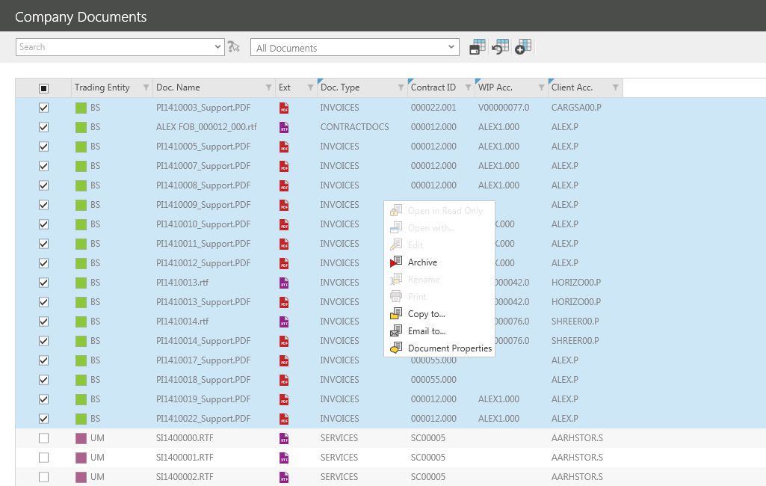

From the right click menu select Archive.

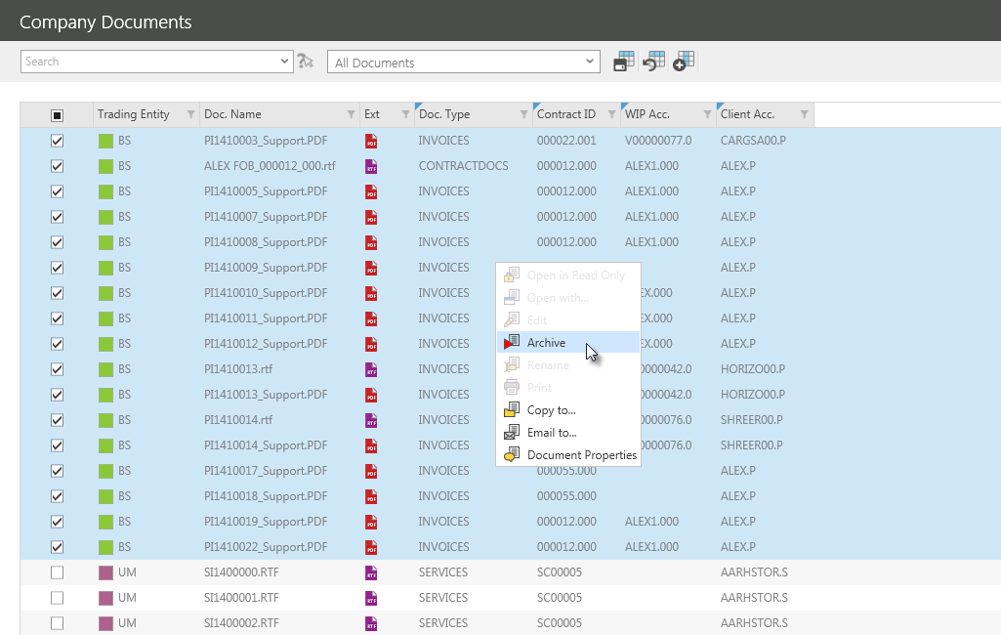

The following message should appear:

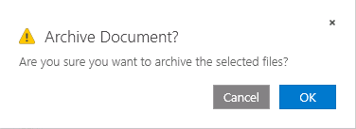

Click to continue, and the following message should appear:

Click to continue.

The document will now no longer be visible in Company Documents, but it can be viewed in Archived Documents.

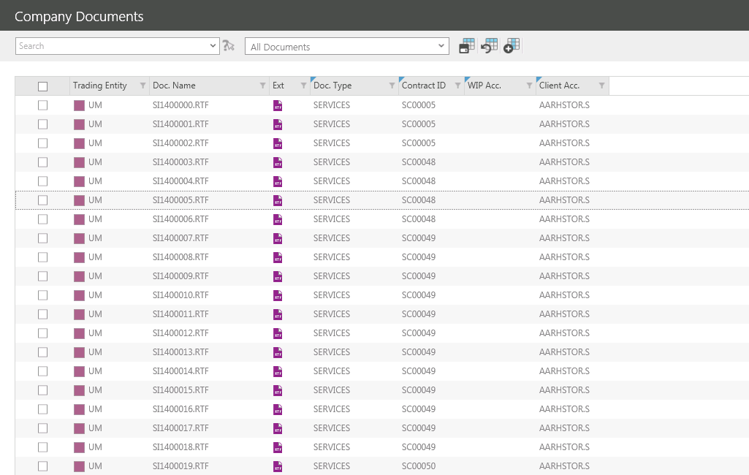

Archived Documents
Archived Documents will display a list of all documents that have been archived from Company Documents.

This screen enables users to view and unarchive documents.

LAUNCHING ARCHIVED DOCUMENTS
To launch the DOCMAN Menu click in the Navigation Panel.

Click to view a list of unindexed documents.

UNARCHIVE DOCUMENTS
To unarchive an archived document right click the relevant document.

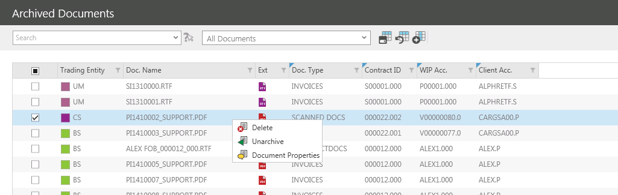

From the right click menu select Unarchive.

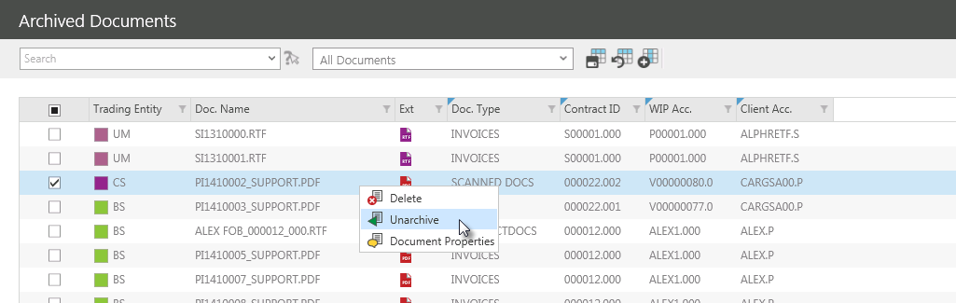

The following message should appear:

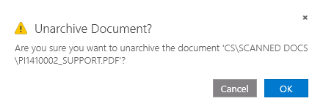

Click to continue, and the following message should appear:

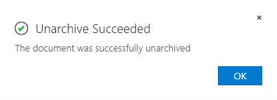
Click to continue.

The document will now no longer be visible in Company Documents, but it can be viewed in Archived Documents.

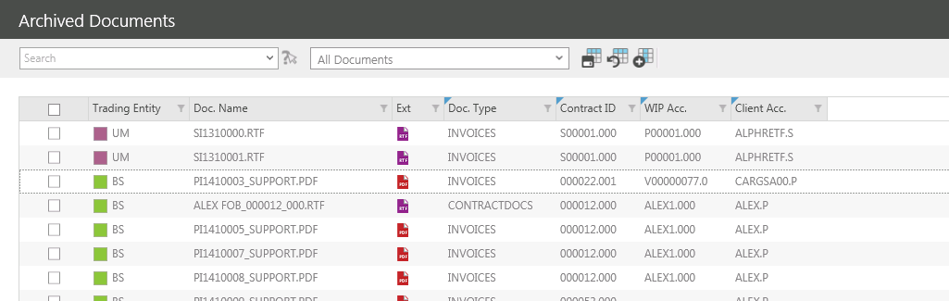

To unarchive a group of documents ensure the ticket box for each of the documents to be unarchived is ticketed.

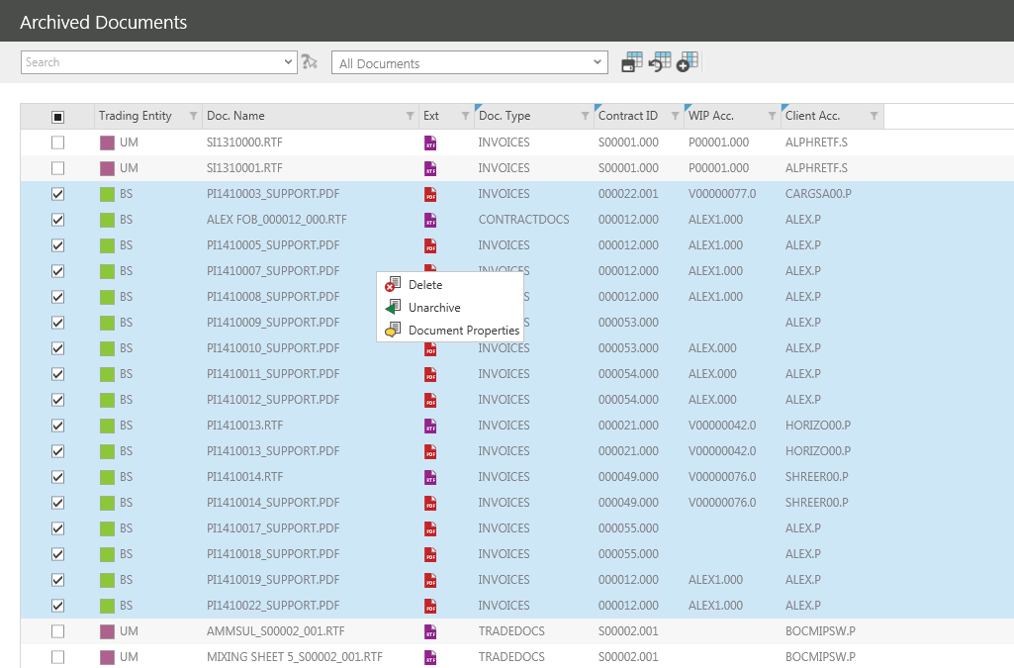

To archive the Company Documents, right click on the selected documents.

From the right click menu select Unarchive.

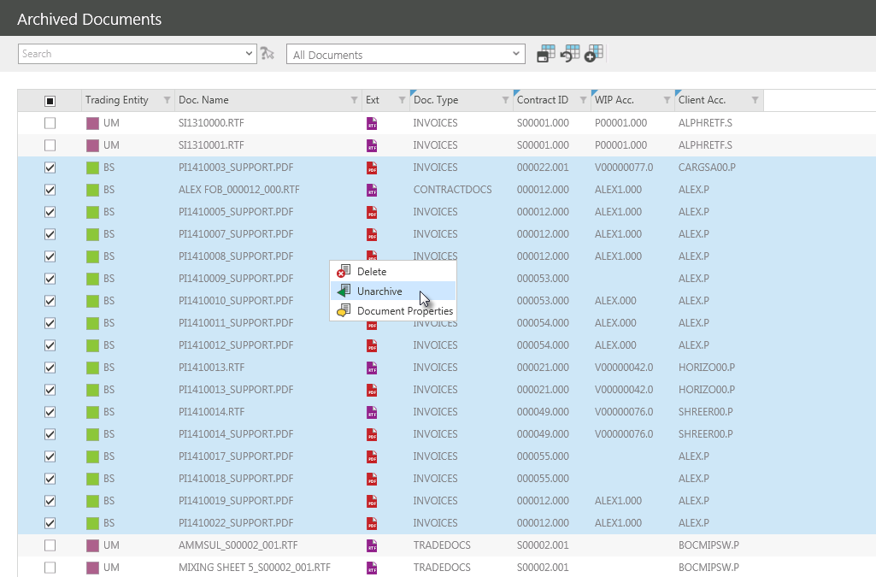

The following message should appear:

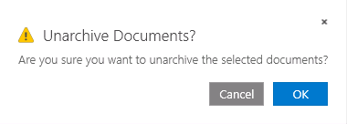

Click to continue, and the following message should appear:

Click to continue.

The document will now no longer be visible in Company Documents, but it can be viewed in Archived Documents.

